N830EH
Aircraft Operating Handbook

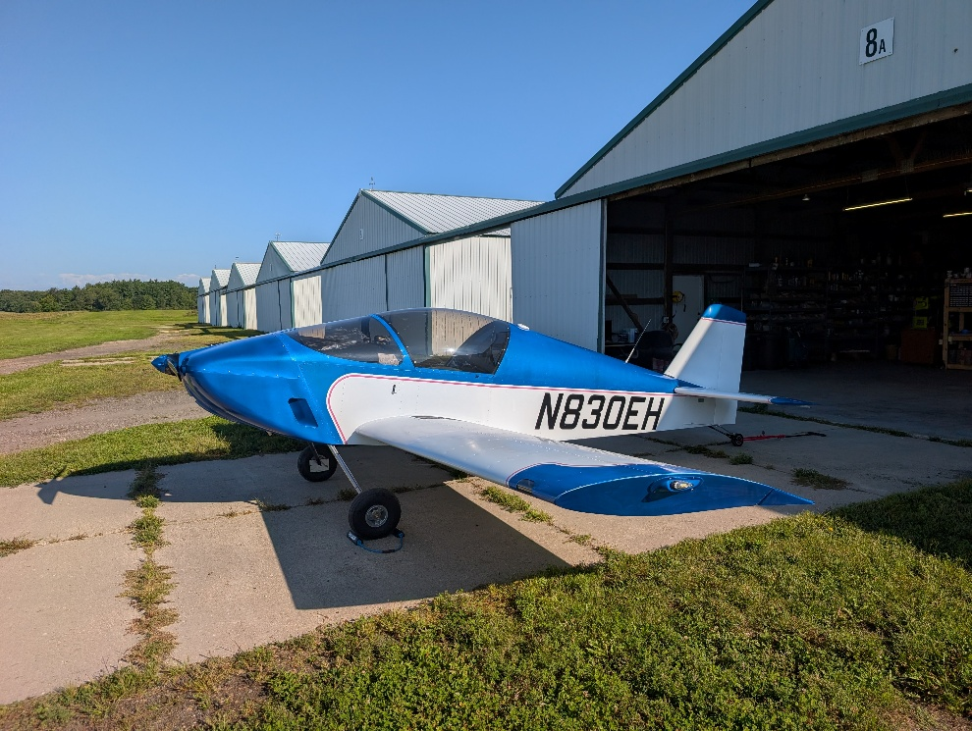

Kit Manufacturer:  Kit Model:  Kit Serial:  Kit Builders: | Sonex Aircraft  Sonex B (A Model Conversion)  0849B  Evan Krueger and Hannah Silber


List of Revisions
Version | Date | Section(s) | Reason
A | 08/27/2026 | All | Initial Issuance

List of Effective Sections
Section | Version | Date
Front Matter | A | 08/27/2026
1 – General Information | A | 08/27/2026
2 – Limitations | A | 08/27/2026
3 – Emergency Procedures | A | 08/27/2026
4 – Normal Procedures | A | 08/27/2026
5 - Performance | A | 08/27/2026
6 – Weight and Balance | A | 08/27/2026
7 – Airplane & Systems Description | A | 08/27/2026
8 - Handling, Servicing, and Maintenance | A | 08/27/2026

Introduction
This flight manual has been prepared using GAMA Specification #1 for Pilot’s Operating Handbook, Advisory Circulars 25.1581-1, 90-89C, and the Sonex Sonex-B Flight Manual by Evan Krueger and Hannah Silber, the original builders, and describes the operation and performance of N830EH, a B-Model Sonex, which has been constructed carefully and in accordance with the plans. Read this handbook carefully as it provides operational procedures specific to this aircraft. Please note that this Aircraft Operating Handbook (AOH) differs from traditional Aircraft Flight Manuals (AFMs) in that this manual is not reviewed or approved by the FAA.
While this handbook contains basic information and guidance on operating this specific aircraft, it is not a comprehensive guide on all aspects and components of the aircraft. More component specific information is available from manufacturers such as Jabiru, Garmin, and Dynon, via their pilots guides, installation manuals, and maintenance manuals. The following manuals can be referenced for additional information on the systems and components installed in this aircraft:
- ACK Technologies E-04 ELT Installation and Operation Manual (E04M)
- Dynon SkyView HDX Pilot’s User Guide (102949-016)
- EarthX Lithium Battery User’s Manual (111017_AD)
- Garmin GPS 175 Pilot’s Guide (190-02488-01)
Ultimately, this manual is one of many resources available to the pilot in command, who is responsible for ensuring the information is applicable to the aircraft's current condition and the planned flight.

This flight manual must be kept in the aircraft at all times.

Table of Contents
List of Revisions ii
List of Effective Sections ii
Introduction iii
Table of Contents iv
Section 1: General Information 1
Specifications 1
Airplane Three View 2
Turning Radius 3
Build Information 3
Section 2: Limitations 1
Airspeed Limitations 1
Airspeed Indicator Markings 1
Power Plant Limitations 2
Powerplant Instrument Markings 3
Weight and Balance Limitations 3
Altitude Limitations 3
Maneuver Limits 4
Kinds of Operation 4
Airworthiness Certificate Operating Limitations 5
Placards 5
Section 3: Emergency Procedures 1
Airspeeds For Emergency Operation 1
Engine Fire During Start 1
Engine Failure Immediately After Takeoff 1
Engine Failure In Flight 1
Engine Fire In Flight 2
Cabin Fire In Flight 2
Emergency Landing Without Engine Power 2
Precautionary Landing With Engine Power 3
Ditching 3
Landing With a Flat Tire 3
Voltage/Amperage Issues 4
Airspeed Altitude, and/or Attitude Unreliable 4
Autopilot Fault 4
Autopilot Jam 4
Spin Recovery 4
Section 4: Normal Procedures 1
Airspeeds for Normal Operation 1
Preflight Inspection 1
Engine Starting 3
Before Takeoff 4
Normal Takeoff 4
Short Field Takeoff 4
Climb 5
Cruise 5
Before Landing 5
Normal Landing (3-Point) 5
Normal Landing (Wheel Landing) 5
Short Field Landing 6
Balked Landing 6
After Landing 6
Shutdown 6
Section 5: Performance 1
Introduction 1
Temperature Conversion Table 2
Crosswind Component Table 3
Density Altitude Table 4
Airspeed Calibration Table 5
Stall Speeds 5
Takeoff Distance 5
Maximum Rate of Climb 5
Time, Fuel, Distance to Climb 5
Cruise Performance 5
Maximum Glide 5
Landing Distance 5
Section 6: Weight and Balance 1
Introduction 1
Airplane Weighing Procedures 1
Weight and Balance Record 2
Weight and Balance Report 3
Center of Gravity Limits 4
Weight and Balance Loading Form 5
Equipment List 6
Section 7: Airplane & Systems Description 1
Introduction 1
Airframe 1
Flight Controls 2
Trim Systems 3
Wing Flaps 3
Instrument Panel 4
Flight Instruments 7
Avionics 10
Autopilot 12
Emergency Locator Transmitter (ELT) 13
Magnetic Compass 14
Pitot-Static System 14
Stall Warning System 15
Landing Gear 15
Aircraft Canopy 16
Seats 17
Seatbelts 17
Baggage Compartment 18
Cabin Safety Equipment 18
Engine 19
Propeller 22
Fuel System 23
Brake System 24
Electrical System 24
Lighting Systems 28
Environmental System 29
Smoke System 29
Section 8: Handling, Servicing, and Maintenance 1
Introduction 1
Handling 1
Taxiing 1
Towing 2
Parking and Tie Down 3
Leveling and Jacking 3
Servicing 4
Tires 4
Brakes 4
Propeller 4
Oil 4
Fuel 5
Battery 5
Aircraft Exterior 6
Canopy and Windshield 6
Maintenance 7
Maintenance Reference Documents 7
Airframe Inspection Scope and Interval 8
Powerplant Inspection Scope and Interval 8

[This page left blank]

Section 1: General Information

Specifications
Engine
Engine Manufacturer ……......……………………………………………………...………… Jabiru
Engine Model …………………………………………………………………………………… 3300L
Number of Cylinders ……………………………………………………………………..…………. 6
Horsepower Rating ………………………………………………………. 120 hp @ 3,300 RPM
Displacement ……………………………………………………..………………………….. 201.4 ci
Bore ………………………………………………………………...………………………………. 3.84”
Stroke ………………………………………………………...…………………………………….. 2.91”
Compression Ratio …………………………………………………...……………………………. 8:1
Ignition …………………………………………….. Jabiru Dual Ignition, Battery Independent
Generator Type …………........................................… Jabiru single phase AC generator
Generator Output ………………….…………………………………………….....… 17 Amps DC
Carburetor ………………………….……………………..…… Aero Conversions AeroInjector
Fuel System ………………………….………………………………..………………….. Gravity Fed

Propeller
Propeller Type …………………………………………………………….. Fixed Pitch, Two Blade
Propeller Make/Model ……………………………………………………...... Prince 54/60PK
Diameter ……………………………………………………………………………………...…… 54.0”

Fuel
Total Capacity ……………………………………………………………...…... 20.0 U.S. Gallons
Total Usable …………………………………………………………………...… 20.0 U.S. Gallons
Approved Fuel Grades ……………………………………………. AVGAS 100LL/100/130
MOGAS above 95 Octane RON (AKI 90)

NOTE: Reference Jabiru Service Letter JSL007 for more information on using MOGAS

Oil
Oil Capacity ………………….…………………………………………………………... 3.7 Quarts
Oil Grades ……………………………………………..……………. W100, W100+, 15W-50,
Or SAE J-1899 equivalent

Aircraft
Length ………………….…………………………………………………………...................... 18’ 1”
Wing Span ………………………………………………………………………………………. 22’ 0”
Wing Area ………………………………………………………………………………… 98.0 Sq. ft.
Wing Loading…………………………………………………………………… 12.45 lb per sq. ft.
Baggage Area ……………………………………………………………..……….. 8.3 cubic feet

Airplane Three View
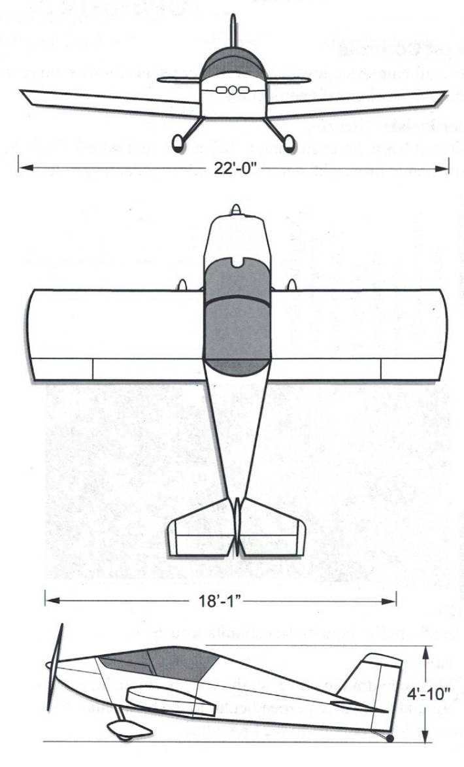

Turning Radius

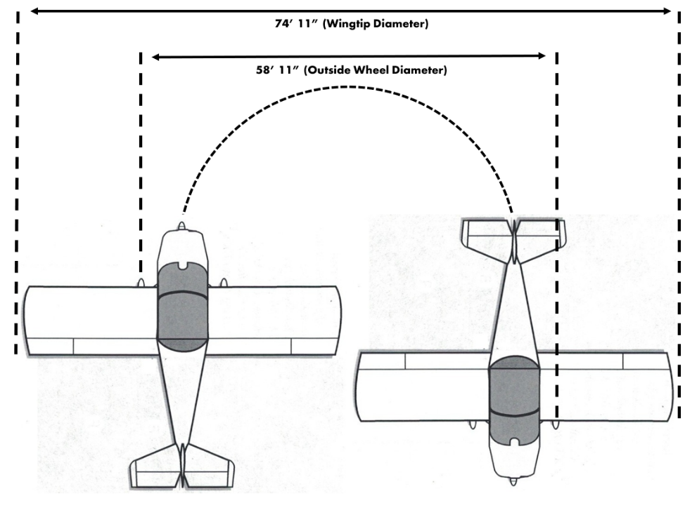Build Information
Source of Plans ……………………………………………………………………….. Sonex Aircraft
511 Aviation Road
Oshkosh, WI 54902
Aircraft Type ……………………………………….. Sonex-B (Original Sonex-A Conversion)
Aircraft Serial Number ……………………………………………… 0849B (Originally 0849)
Constructed By ………………………………………………. Evan Krueger and Hannah Silber
538 Greenview Dr
Evansville, WI 53536
(608) 616-9391

Engine Type …………………………………………………………………………...… Jabiru 3300L
Engine Serial Number ……………………………………………………… 33L-131 (33A-2713)
Engine Build Date …………………………………………………………………. December 2014

Paint Manufacturer and Type ……………………… Eastwood 3:1 Single Stage Urethane
Paint Colors ………………………………………………………. Rat Rod Matte Black (Interior)
Pure White (Exterior Base)
Caribbean Bay Blue Pearl (Exterior Accent)
Vinyl Stripe Color …………………………………………………….. Avery A-508SC: Soft Pink

Construction Start ………………………………………………….…………….. March 25, 2024
Construction End ……………………………………………………………….… August 27, 2026
Airworthiness Certificate Issued ……………………………………………………………..… XXX
First Flight ……………………………………………………………………………………………... XXX
Flight Testing Complete …………………………………………………………………………… XXX

Section 2: Limitations

Airspeed Limitations
Speed | KIAS | Remarks
V_{NE} | 171 | Never Exceed Speed is the speed limit that may not be exceeded at any time
V_{NO} | 118 | Maximum Structural Cruising Speed is the speed that should not be exceeded except in smooth air, and then only with caution
V_{A} | 108 | Maneuvering Speed is the maximum speed at which full control travel may be used. Below this speed the airplane stalls before limit loads are reached. Above this speed, full control movements can damage the airplane.
V_{FE} | 86 | Maximum Flap Extended Speed is the highest speed permissible with wing flaps extended

Airspeed Indicator Markings
Marking | KIAS | Remarks
Red Line | 171 | Never Exceed Speed. Maximum speed for all operations.
Yellow Arc | 118 - 171 | Caution Range. Operations must be conducted with caution and only in smooth air.
Green Arc | 40 - 118 | Normal Operating Range. Lower limit is the maximum weight stall with flaps retracted. Upper limit is the maximum structural cruising speed.
White Arc | 35 - 86 | Full Flap Operating Range. Lower limit is the most  adverse stall speed in the landing configuration.  Upper limit is the maximum speed permissible with  flaps extended.

Power Plant Limitations
Engine Manufacturer/Model……………………………………………………… Jabiru 3300L
Maximum Power …………………………………………………………… 120 hp @3300 RPM
Full Power Static RPM ………………………………………………………. 2600 – 2800 RPM

Oil
Oil Capacity ………………………………………………………………………………. 3.7 Quarts
Oil Temperature – Minimum for Takeoff …………………………………………………. 122°F
Oil Temperature – Continuous …………………………………………………… 176°F - 212°F
Oil Temperature – Maximum Peak ……………………………………………………….. 244°F
Oil Pressure – Starting and Warm Up …………………………………………………… 76 psi
Oil Pressure – Idle ……………………………………………………………………………… 12 psi
Oil Pressure – Normal Operations ………………………………………………… 32 – 51 psi
Oil Consumption …………………………………………………………..… 0.1 Quart/hr (max)
Oil Standard ……………………………………………………..……………………… SAE J-1899

Fuel
Fuel Consumption – Takeoff ………………………………………………….. 10.0 – 10.6 gph
Fuel Consumption – 75% Power……………………………………………..….. 6.1 – 7.7 gph
Fuel Pressure ……………………………………………………………………….. 0.75 – 5.00 psi
Fuel Grades .…..…………………………..…………………………. AVGAS 100LL/100/130
MOGAS above 95 Octane RON (AKI 90)

Cylinder Head Temperatures (CHTs)
CHT – Maximum Continuous …………………………………………………………….… 356°F
CHT – Maximum Peak ……………………………………………………………………..… 392°F

NOTE: Time with CHT at between 356°F and 392°F is not to exceed 5 minutes.

Exhaust Gas Temperatures (EGTs)
EGT – Minimum ………………..…………………………………………………………..… 1,112°F
EGT – Maximum Continuous ……………………………………………………………. 1,292°F
EGT – Maximum Peak …………………………………………………………………….. 1,328°F

Powerplant Instrument Markings
Instrument | Red Line (Min) | Green Arc (Normal) | Yellow Arc (Caution) | Red Line (Max)
Tachometer (RPM) |  | 900 – 3300 |  | 3300
Cylinder Head Temp. (°F) |  | 200 - 356 | 356 | 392
Exhaust Gas Temp. (°F) | 1112 | 1112 - 1292 | 1292 - 1328 | 1328
Fuel Flow (gph) |  | 6.1 – 7.7 |  | 10.6
Oil Temp. (°F) | 122 | 176 - 212 | 212 - 244 | 244
Oil Pressure (psi) | 12 | 32 - 51 | 12 - 32  51 - 76 | 76
Fuel Quantity (gal) | 0 | 3 - 20 | 0 - 3
Voltmeter (v) |  | 13.9 – 14.6 | 12.5 – 13.9 | 14.6

Weight and Balance Limitations
Max Gross Weight (Utility Category) ……………………….………………………. 1,220 lbs
Max Gross Weight (Aerobatic Category) ……………………………………………. 950 lbs
Empty Weight ……………………………………….……………………………………. 725.68 lbs
Useful Load (Utility Category) ………………………………………………………… 494.32 lbs
Max Weight in Baggage Compartment ………………………………………………… 40 lbs
Center of Gravity Limits (Utility Category) ………………………………. 63.55” to 70.03”
20% MAC to 32% MAC
Center of Gravity Limits (Aerobatic Category) ……...………………….. 65.17” to 68.41”
23% MAC to 29% MAC

Altitude Limitations
Service Ceiling …………………………………………………………………………….. XX,XXX FT
Absolute Ceiling …………………………………………………………………………… XX,XXX FT

Maneuver Limits
Utility Category
When operating in the utility category, no aerobatic maneuvers, including intentional spins, are permitted. In the utility category, the following maximum flight load factors apply:

Flight Load Factors (Utility Category) ……………………………………….… -2.2g / +4.4g

Aerobatic Category
Aerobatics that may impose high loads must not be attempted. The airplane is clean in aerodynamic design and will build up speed quickly with the nose down. Proper speed control is essential for execution of any maneuver and care must be taken to avoid excessive speed which can impose excessive loads. In the execution of all maneuvers, avoid abrupt use of controls. In the aerobatic category, the following maximum flight load factors apply:

Flight Load Factors (Aerobatic Category) ……………………………….… -3.0g / +6.0g

When operating in the aerobatic category, no aerobatic maneuvers are approved excepts those listed below. While executing these maneuvers, do not use abrupt control inputs:

- Chandelles  - Steep Turns (beyond 60° of bank)  - Loops  - Barrel Rolls | - Lazy Eights  - Spins  - Aileron Rolls  - Stalls

Kinds of Operation
This aircraft is approved for Day and Night VFR and IFR when compliant with the applicable FAR Part 91 regulations.

Airworthiness Certificate Operating Limitations
As a result of an airworthiness inspection conducted by a designated airworthiness representative to the Federal Aviation Administration, the following operating limitations were imposed on the aircraft:

[To Be Updated]

NOTE: The above limitations listed above are for reference only and do not satisfy the requirement of maintaining a current copy onboard the aircraft.

Placards
The following information must be displayed in the form of composite or individual placards:

- In full view of all aircraft occupants on the instrument panel:

“This aircraft does not comply with federal safety regulations for standard aircraft”

- On the left-hand wing walk area:

“EXPERAMENTAL”

- On the left-hand flap:

“NO STEP”

- On the oil service door:

“Engine Oil
Capacity: 3.7 Quarts
Type: AeroShell 15W-50
See AOH for Approved Oil Types”

- On the fuel service door:

“Fuel
Capacity: 20.0 U.S Gallons
Avgas 100LL/100/130 or
Mogas above 95 RON (90 AKI)
See AOH for Approved Fuel Types”

- On the parking brake handle:

“Parking Brake
Pull On”

Section 3: Emergency Procedures
Emergencies caused by aircraft or engine malfunctions are extremely rare if proper pre-flight inspections and maintenance are carried out. Flight planning, together with good judgement, can minimize enroute weather emergencies. However, if an emergency should arise, the basic guidelines described in this section should be considered and applied as necessary to correct the problem. Procedures in this portion of the manual shown in bold faced type are immediate action items which should be committed to memory.

Airspeeds For Emergency Operation
Maneuvering Speed …………………………………………………………….……….. 108 KIAS
Best Glide ……………………………………………………………………………………… 70 KIAS
Emergency Landing (Engine-out) ………………………………………………………. 60 KIAS

Engine Fire During Start
- Mixture ……………………………………………………………………………. CUTOFF
- Fuel Valve ………………………………………………………………………………. OFF
- Throttle …………………………………………………………………………. FORWARD
- Starter ………………………………………………………………………………. CRANK

Engine Failure Immediately After Takeoff
- Airspeed …………………………………………………………………………… 70 KIAS
- Mixture ……………………………………………………………………………. CUTOFF
- Fuel Valve ………………………………………………………………………………. OFF
- Ignition Switch …………………………………………………..……………………. OFF
- Flaps ………………………………………………………………………. AS REQUIRED
- Master Switch ………………………………………………………………………… OFF

Engine Failure In Flight
- Airspeed ………………………………………………………… BEST GLIDE, 70 KIAS
- Mixture ……………………………………………………………………. AS REQUIRED
- Fuel Valve ……………………………………………………………………………….. ON
- Ignition Switch …………………………………………………..… CHECK L, R, BOTH
NOTE: If the propeller is windmilling, the engine will restart automatically within a few seconds. If the propeller has stopper, turn the ignition switch to START, advance throttle slowly from idle, and lean the mixture from full rich as required for smooth operation.

Engine Fire In Flight
- Fuel Valve ……………………………………………………………………………….. OFF
- Mixture ……………………………………………………………………… IDLE CUTOFF
- Ignition Switch ……………………………………………………………………….... OFF
- Master Switch …………………………………………………………………………. OFF
- Airspeed …………………………………………………………………………… 70 KIAS
If fire is not extinguished, increase airspeed
- Cabin Vents ……………………………………………………………………….... CLOSE
- Landing Site …………………………………………………..…………………… SELECT
- Forced Landing Procedure ………………………………………………….. EXECUTE

Cabin Fire In Flight
- Master Switch …………………………………………………………………………. OFF
- Cabin Vents ………………………..…………………………………………….... CLOSE
- Fire …..…………..………………………………………………………….. EXTINGUISH
- Cabin Vents …………………………………………………………………………. OPEN
Only if/when fire is completely extinguished
- Emergency ………………………………………………………………………. DECLARE
- Land ……………………………………..…………………… AS SOON AS POSSIBLE

Emergency Landing Without Engine Power
- Emergency ………………………………………………………………………. DECLARE
- Fuel Valve ……………………………………………………………………………….. OFF
- Mixture ……………………………………………………………………… IDLE CUTOFF
- Ignition Switch ……………………………………………………………………….... OFF
- Master Switch …………………………………………………………………………. OFF
- Airspeed …………………………………………………………………………… 60 KIAS
- Landing …………………………………….... UPWIND, FULL STALL, STICK BACK
- Brakes ………………………………………………..…………………… APPLY HEAVILY
- ELT ………………………………………………………………………………… ACTIVATE

Precautionary Landing With Engine Power
- Airspeed …………………………………………………………………………… 74 KIAS
- Selected Field …….……………………………………….. FLY OVER AND INSPECT
- Emergency ………………………………………………………………………. DECLARE
- Wing Flaps ……………………………………………………………….. AS REQUIRED
- Approach …………………………………………………………………………. 60 KIAS
- Master Switch …………………………………………………………………………. OFF
- Landing …………………………………….... UPWIND, FULL STALL, STICK BACK
- Ignition Switch ……………………………………………………………………….... OFF
- Brakes ………………………………………………..…………………… APPLY HEAVILY
- ELT ………………………………………………………………………………… ACTIVATE

Ditching
- Emergency ………………………………………………………………………. DECLARE
- Wing Flaps ……………………………………………………………………………… 30°
- Power …………………………………………………………. 300 Ft/Min AT 60 KIAS
- Approach …………………………………………….… Heavy Winds: INTO WIND
Light Winds: PARALLEL TO SWELLS
- Touchdown ……………………………………………………………. LEVEL ATTITUDE
- Master Switch …………………………………………………………………………. OFF
- ELT ………………………………………………………………………………… ACTIVATE
- Airplane ……………………………………………………………………….. EVACUATE

Landing With a Flat Tire
- Approach……………………………………………………………………….. NORMAL
- Wing Flaps ……………………………………………………………………………… 30°
- Touchdown …………………………………………………………. GOOD TIRE FIRST
Hold airplane off flat tire with aileron

Voltage/Amperage Issues
- Alternator Reset Button…………………………………………………………….. PUSH
- Voltage Gauge …………………………………………………………………… CHECK
If voltage and/or amperage still abnormal:
- Nonessential Electrical Equipment ………………………………………………. OFF
- Flight ………………………………………………. TERMINATE as soon as practical

Airspeed Altitude, and/or Attitude Unreliable
- Autopilot …………………………………………………………………. DISCONNECT
- Pitot Heat ………………………………………………………………………………… ON

Autopilot Fault
- Autopilot …………………………………………………………………. DISCONNECT
- Aircraft …………………………………………………………………… FLY MANUALLY

Autopilot Jam
- Autopilot …………………………………………………………………. DISCONNECT
- Flight Controls ……………………………………….. APPLY BREAK-AWAY FORCE
- Aircraft …………………………………………………………………… FLY MANUALLY
- Autopilot ………………………………………………………………………… PULL C/B
NOTE: When pilot applies force to flight control system, shear screw will break and safely disconnect flight controls from malfunctioning Autopilot servo. Once shear screw breaks, pilot needs to relax flight control input to avoid over correction. The flight controls will then operate normally.

Spin Recovery
- Power .…………………………………………………………………………………… IDLE
- Ailerons ………………………………………………………………………….. NEUTRAL
- Rudder ……………………………………… FULL RUDDER OPPOSITE ROTATION
- Elevator ……………………………… STICK FORWARD BRISKLY AFTER ¼ TURN
- Controls ………..… NEUTRALIZE AFTER ROTATION STOPS AND RECOVER
NOTE: Intentional spins in the utility category are prohibited. Spins are approved only in the aerobatic category

[This page left blank]

Section 4: Normal Procedures

Airspeeds for Normal Operation
Takeoff Rotation …………………………………..………………………….……….. 52 - 57 KIAS
Normal Climb …………………………………………………………………………… XX -XX KIAS
Best Rate-of-Climb (V_{Y}) ………………………………………………………………….…. XX KIAS
Best Angle-of-Climb (V_{X}) …………………………..………………………………………. XX KIAS
Normal Landing Approach (Flaps Up) .………………………………………………. 65 KIAS
Normal Landing Approach (Flaps 30°) ...……………………………………………. 60 KIAS
Short Field Landing Approach (Flaps 30°) ..…………………………………………. 52 KIAS
Max Turbulent Air Penetration Speed ………………………………………………… 108 KIAS
Max Demonstrated Crosswind Component ………………………………..………… 15 KIAS

Preflight Inspection
Before carrying out preflight inspections, ensure that all required maintenance has been accomplished and review your flight plan and compute weight and balance. Visually check aircraft for general condition during the walk around inspection. In cold weather, remove all frost, ice, or snow from the wings, tail, and control surfaces. Also, make sure that surfaces contain no internal accumulation of ice or debris.
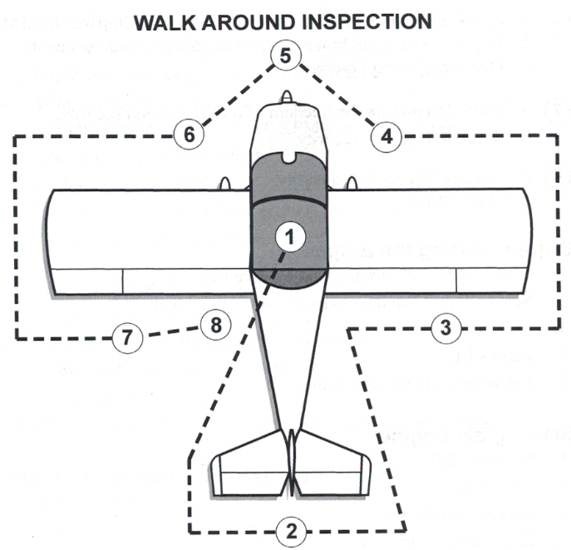
- CABIN
  - Canopy and Lock Mechanism ………………………………… INSPECT
  - Required Documents ………………………………………… ON BOARD
  - Ignition Switch …………………………………………………………….. OFF
  - Mixture ………….……………………………………………………. CUTOFF
  - Fuel Valve ………………………………………………………………….. OFF
  - Circuit Breakers ……………………………………………………………... IN
  - Avionics Master Switch ………………………………………………… OFF
  - Master Switch ……………………………………………………………... ON
  - Flaps ……………………………………………………………………. DOWN
  - Aircraft Times …………………………………………………………… NOTE
  - Fuel Quantity …………………………………………………………. CHECK
  - Lights …………………………………………………. CHECK OPERATION
  - Pitot Heat ……………………………………………. CHECK OPERATION
  - Master Switch …………………………………………………………….. OFF
- EMPENAGE
  - ELT Antenna …………………………………………………………… CHECK
  - Rudder Gust Lock …………………………………………………. REMOVE
  - Tiedown Rope ……………………………………………………… REMOVE
  - Tail Wheel Assembly ……………………………………………….. CHECK
  - Rudder and Elevator ……………………………………………….. CHECK
  - OAT Probe …………………………………………………………….. CHECK
- RIGHT WING TRAILING EDGE
  - Right Flap ……………………………………………………………. SECURE
  - Right Aileron …………………………………………………………. CHECK
- RIGHT WING
  - Tiedown Rope ……………………………………………………… REMOVE
  - Pitot Cover ………………………………………………………….. REMOVE
  - Pitot Tube ………………………………………………………………. CHECK
  - Main Tire ………………………………………………………………. CHECK
  - Wheel and Gear Fairings ………………………………………… CHECK
  - Gear Attachments …………………………………………………... CHECK
- NOSE
  - Exhaust Pipes …………………………………………………………. CHECK
  - Engine Components ………………………………………………... CHECK
  - Oil Level ……………………………………………………………….. CHECK
  - Propeller and Spinner ……………………………………………… CHECK
  - Air Inlets ……………………………………………………………….. CHECK
  - Fuel Sump ………………………………………….. DRAIN AND SAMPLE
  - Fuel Door …………………………………………………………….. SECURE
  - Antennas ……..……………………………………………………….. CHECK
- LEFT WING
  - Gear Attachments …………………………………………………... CHECK
  - Wheel and Gear Fairings ………………………………………… CHECK
  - Main Tire ………………………………………………………………. CHECK
  - Tiedown Rope ……………………………………………………… REMOVE
- LEFT WING TRAILING EDGE
  - Left Aileron ……………………………………………………………. CHECK
  - Left Flap ………………………………………………………………. SECURE
- FINAL ITEMS
  - Covers ………………………………………………….. VERIFY REMOVED
  - Tiedowns ………………………………………………. VERIFY REMOVED
  - Chocks ………………………………………………………………. REMOVE

Engine Starting
- Preflight Inspection …………………………………………………………. COMPLETE
- Passenger Briefing …………………………………………………………. COMPLETE
- Seat Belts ………………………………………………………….. ADJUST AND LOCK
- Parking Brake …………………………………………………………………………… SET
- Electrical Equipment …………………………………………………………………. OFF
- Master Switch ………………………………………………………………………….. ON
- Nav Lights ……………………………………………………………………………….. ON
- Propeller Area ……………………………………………………………………… CLEAR
- Canopy ……………………………………………………………… LATCH AND LOCK
- Throttle ……………………………………………………………………………. OPEN ¼”
- Fuel Valve ……………………………………………………………………………….. ON
- Mixture …………………………………………………………………………………. RICH
- Starter ……………………………………………………………………………. ENGAGE
- Oil Pressure …………………………………………………… CHECK (5 SECONDS)
- Throttle …..…………………………………………………………………….. 1,200 RPM
- Avionics Master ……………………………………………………………………….. ON
- Flaps ………………………………………………………………………………. RETRACT
- Mixture ………………………………………………………………………………… LEAN

Before Takeoff
- Parking Brake …………………………………………………………………………… SET
- Flight Controls …………………………………………………………………….. CHECK
- Instruments .................................................................................... CHECK/SET
- GPS, Radio, and Transponder …………………………………………………….. SET
- Autopilot ………………………………………………………. TEST (SEE SECTION 7)
- Mixture …………………………………………………………………….. AS REQUIRED
- Throttle …………………………………………………………………………. 2,000 RPM
- Magnetos …………………………………………. CHECK (100 RPM MAX DROP)
- Engine Instruments ……………………………………………………………….. CHECK
- Throttle ……………………………………………………………………….. IDLE CHECK
- Throttle …………………………………………………………………………. 1,200 RPM
- Trim ………………………………………………………………………………………… SET
- Canopy ……………………………………………………….. LATCHED and LOCKED

Normal Takeoff
- Canopy ………………………………………………………………… VERIFY LOCKED
- Flaps ……………………………………………………………………………………….. UP
- Lights ……………………………………………………………………………………… ON
- Mixture ……………………………………………………………………. AS REQUIRED
- Throttle ………………………………………………………………………… FULL OPEN
- Elevator ………………………………………………………………………….… LIFT TAIL
- Rotate ………………………………………………………………………………. 57 KIAS
- Initial Climb ………………………………………………………………… XX KIAS (V_{Y})

Short Field Takeoff
- Canopy ………………………………………………………………… VERIFY LOCKED
- Flaps ……………………………………………………………………………………….. XX
- Lights ……………………………………………………………………………………… ON
- Mixture ……………………………………………………………………. AS REQUIRED
- Brakes ……………………………………………………………………………………. SET
- Throttle ………………………………………………………………………… FULL OPEN
- Brakes ……………………………………………………………………………… RELEASE
- Elevator …………………………………………………….. LIFT TAIL SLIGHTLY HIGH
- Rotate ………………………………………………………………………………. 52 KIAS
- Initial Climb ………………………………………………………………… XX KIAS (V_{X})
- Airspeed Over Obstacle ………………………………………………… XX KIAS (V_{Y})
- Flaps ………………………………………………………………………………. RETRACT

Climb
- Airspeed …………………………………………………………………… XX – XX KIAS
- Lights ………………………………………………………………………. AS REQUIRED
- Mixture …………………………………… AS REQUIRED (LEAN ABOVE 3,000’)

Cruise
- Power ……………………………………………………………… SET PER SECTION 5
- Lights ………………………………………………………………………. AS REQUIRED
- Mixture …………………………………… AS REQUIRED (LEAN ABOVE 3,000’)
- Fuel Quantity …………………………………………………………………. MONITOR

Before Landing
- Fuel Valve …………………………………………………………………….. VERIFY ON
- Mixture …………………………………………………………………….. AS REQUIRED
- Seat Belts ………………………………………………………………………... SECURED
- Lights ……………………………………………………………………………………… ON
- Autopilot ………………………………………………………………………………… OFF

Normal Landing (3-Point)
- Traffic Pattern Airspeed ………………………………………………………… 80 KIAS
- Flaps ……………………………………………………………………….. AS REQUIRED
- Final Approach Airspeed ……………………………………………… 60 – 65 KIAS
- Throttle …………………………………………………………………………….. CLOSED
- Touchdown …………………………………………. FULL STALL WITH STICK BACK
- Brakes ……………………………………………………………………… AS REQUIRED

Normal Landing (Wheel Landing)
- Traffic Pattern Airspeed ………………………………………………………… 80 KIAS
- Flaps ……………………………………………………………………….. AS REQUIRED
- Final Approach Airspeed ……………………………………………………... 60 KIAS
- Throttle …………………………………………………………………………….. CLOSED
- Touchdown …………………………………………………….. MAIN WHEELS FIRST
- Landing Roll ……………………. STICK BACK SLOWLY, LOWER TAIL GENTLY
- Brakes ……………………………………………………………………… AS REQUIRED

Short Field Landing
- Traffic Pattern Airspeed ………………………………………………………… 70 KIAS
- Flaps ………………………………………………………………………………………. 30°
- Final Approach Airspeed ……………………………………………… 52 – 57 KIAS
- Throttle …………………………………………………………………………….. CLOSED
- Touchdown …………………………………………. FULL STALL WITH STICK BACK
- Brakes ……………………………………………………………………… AS REQUIRED

Balked Landing
- Throttle …………………………………………………………………………. FULL OPEN
- Climb Attitude ………………………………………………….. ESTABLISH POSITIVE
- Flaps ……………………………………………………………………. RETRACT TO 10°
- Climb Airspeed …………………………………………………………… XX – XX KIAS
- Flaps ………………………………………………………………………………. RETRACT

After Landing
- Flaps ………………………………………………………………………………. RETRACT
- Lights ……………………………………………………………………….. AS REQUIRED
- Pitot Heat ………………………………………………………………………………... OFF
- Trim …………………………………………………………………………………….. RESET
- Mixture …………………………………………………………………….. AS REQUIRED

Shutdown
- Parking Brake …………………………………………………………………………… SET
- Avionics Master Switch ……………………………………………………………… OFF
- Electrical Switches ……………………………………………………………………. OFF
- Mixture …………………………………………………………………………….. CUTOFF
- Fuel Valve ……………………………………………………………………………….. OFF
- Ignition Switch …………………………………………………………………………. OFF
- Aircraft Times ………………………………………………………………………... NOTE
- Master Switch ………………………………………………………………………….. OFF
- ELT ………………………………………………………………………………. VERIFY OFF
- Control Stick ……………………………………………………………………. SECURED
- Aircraft …………………. SECURED (TIE DOWNS, CHOCKS, AND COVERS)

Section 5: Performance

Introduction
The following performance data, charts, and graphs are presented for operational planning so that operators of this aircraft will know what performance to expect from the airplane under various ambient and field conditions. Performance data is presented for takeoff, climb, and cruise. Reference tables for crosswind calculations, density altitude corrections, and temperature conversions are also provided for flight planning assistance.
Computed performance data in this section is derived from actual flight testing with the airplane and engine in good condition using average piloting techniques. Unless specifically noted in the “Conditions” notes presented with each table, ambient conditions are for a standard day (15°C and 29.92” inHg at sea level).

Temperature Conversion Table

Crosswind Component Table

Density Altitude Table

Airspeed Calibration Table

[Table to be updated after flight testing]

Stall Speeds

[Table to be updated after flight testing]

Takeoff Distance

[Table to be updated after flight testing]

Maximum Rate of Climb

[Table to be updated after flight testing]

Time, Fuel, Distance to Climb

[Table to be updated after flight testing]

Cruise Performance

[Table to be updated after flight testing]

Maximum Glide

[Table to be updated after flight testing]

Landing Distance

[Table to be updated after flight testing]

Section 6: Weight and Balance

Introduction
This section describes the procedure for establishing the basic empty weight and moment of the airplane. Sample forms are provided for reference. Procedures for calculating the weight and moment for various operations are also provided. A comprehensive list of all equipment installed on this airplane is also included in this section.
WARNING: Operating the aircraft at a weight or C.G. outside the deigned envelope is dangerous and is not permitted. Operating near the edges of the design envelope must be done with caution. It is the responsibility of the pilot to ensure the airplane is loaded properly.
While a basic empty weight and center of gravity were established as part of the build process, major modifications, loss of records, addition or replacement of equipment, and weight gain over time may require re-weighing to keep the basic empty weight and center of gravity current.

Airplane Weighing Procedures
- Prepare the aircraft by inflating tires to recommended pressure (see section 8), servicing the brake reservoir and engine oil, draining fuel, raising flaps, and verifying the equipment list is up to date.
- Level the aircraft by placing a spirit level on the upper forward fuselage longerons.
- Place scales under each main wheel and the tail wheel while ensuring scales do not bind.
- With the airplane level, canopy closed, and brakes released, record the weights shown on each scale on the airplane weighing form.
- Record the new weight and C.G. values on the weight and balance record.

Weight and Balance Record
Date | Description of Modification | Weight | Empty CG
08/24/2026 | Initial Weighing of Aircraft | 725.68 lbs. | 64.5845 in

Weight and Balance Report
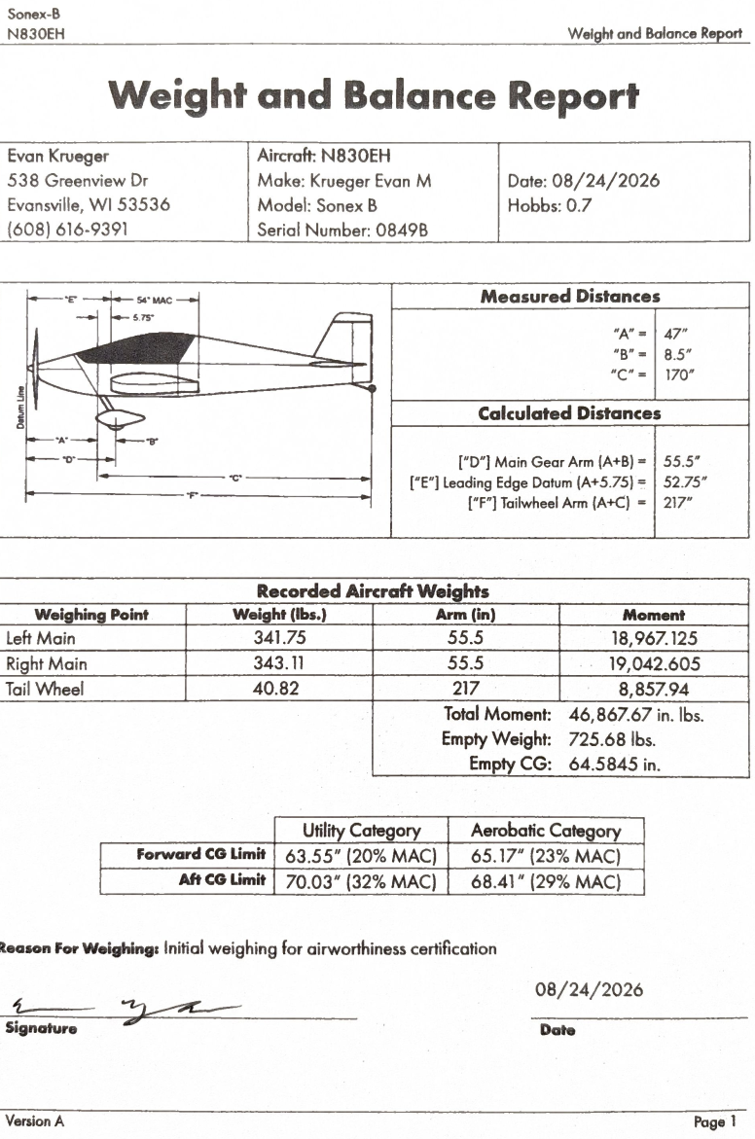

Center of Gravity Limits

 | Utility Category | Aerobatic Category
Forward CG Limit | 63.55” (20% MAC) | 65.17” (23% MAC)
Aft CG Limit | 70.03” (32% MAC) | 68.41” (29% MAC)

Weight and Balance Loading Form

Item | Weight | Arm | Moment
Basic Empty Weight  (Includes unusable fuel and full oil) | 725.68 | 64.5845 | 46,867.67
Fuel  (20 gallons or 120 lbs. max) |  | 45.75
Pilot |  | 76.90
Passenger |  | 76.90
Baggage  (40 lbs. max) |  | 102.00
TOTAL:

Equipment List
The following table is a comprehensive list of all equipment installed in the aircraft. Actual weights and arms along with make, model, and serial number information (when available) for each piece of equipment is also provided for reference purposes.

Item | Description | Weight | Arm | Make/Model (Serial)
22-13-01 | Autopilot Controller | 0.4 | 67.0 | Dynon SV-AP-PANEL/V (14121)
22-15-01 | Autopilot Roll Servo | 2.8 | 71.5 | Dynon SV42EL (25041)
22-15-02 | Autopilot Pitch Servo | 2 | 75.0 | Dynon SV32 (15006)
23-12-01 | Radio Control Panel | 0.3 | 67.0 | Dynon SV-COM-PANEL-OLED/V (6038)
23-12-02 | Com Radio | 0.8 | 90.0 | Dynon SV-COM-T25 (01950)
23-50-01 | Intercom | 0.3 | 67.0 | Dynon SV-INTERCOM-2S (6293)
24-32-01 | EarthX ETX900 Battery | 4.6 | 37.5 | EarthX ETX900
24-32-02 | SkyView Backup Battery | 0.9 | 58.5 | Dynon SV-BAT-320 (56996)
24-36-01 | Voltage Regulator | 0.5 | 35.5 | B&C Specialty Products XB102-1 (2BK50D1U36)
24-36-02 | Filter Capacitor | 0.4 | 35.5 | B&C Specialty Products S8007-3
24-60-01 | Panel Power Outlet | 0.2 | 67.0 | Hapytrip SD16
24-60-02 | Master Switch Panel | 0.2 | 67.0 | Aerosport Various
24-60-03 | Auxiliary Switch Panel | 0.4 | 67.0 | Aerosport Various
24-60-04 | Master Relay | 0.8 | 41.0 | White-Rodgers 11-03161
25-10-01 | iPad Mount System | 0.9 | 68.0 | RAM Mounts RAM-HOL-AP36U
25-10-02 | Bottom Seat Cushion | 3.5 | 79.0 | Sonex SNB-U05
25-10-03 | Back Seat Cushion | 3.6 | 88.0 | Sonex SNB-U05
25-10-04 | LH Fuselage Side Panel | 0.9 | 79.0 | Sonex SNB-F05-10L
25-10-05 | RH Fuselage Side Panel | 1 | 79.0 | Sonex SNB-F05-10R
25-50-01 | Upper Baggage Bulkhead | 1.1 | 114.5 | Sonex SNB-U05
25-50-02 | Lower Baggage Bulkheads | 1 | 114.5 | N/A
25-60-01 | Element Fire Extinguisher | 0.5 | 57.5 | Element E50
25-60-02 | Crash Hammer | 0.3 | 57.5 | Amazon Basics B073JCMTW2
25-62-01 | ELT | 0.7 | 192.0 | ACK Technologies E-04 (048244)
25-62-02 | ELT Battery | 1.2 | 189.5 | ACK Technologies E-04.0 (11/15/2024 00126)
25-62-03 | ELT Antenna | 0.2 | 158.0 | ACK Technologies E-04.8
25-62-04 | ELT Audio Alert Unit | 0.1 | 100.0 | ACK Technologies E-04.7.1
25-62-05 | ELT Control Pannel | 0.1 | 100.0 | ACK Technologies E-04.5
27-50-01 | Flap Switch | 0.1 | 67.0 | Aerosport RV10035-2
30-30-01 | Heated Pitot Controller | 0.4 | 60.8 | Dynon 100640-000 (10710)
31-40-01 | ARINC-429 Adapter | 0.5 | 56.5 | Dynon SV-ARINC-429 (3752)
31-60-01 | SkyView HDX Display | 2.5 | 67.0 | Dynon SV-HDX800 (31551)
31-97-01 | SkyView Network Hub | 0.2 | 96.0 | Dynon SV-NET-HUB
32-42-01 | LH Brake Disk | 0.4 | 55.5 | Aero Conversions ACV-B01-24
32-42-02 | RH Brake Disk | 0.4 | 55.5 | Aero Conversions ACV-B01-24
32-44-01 | LH Tire | 4.7 | 55.5 | Air Hawk 5.00 x 5 (4-ply) (8AB3D25124)
32-44-02 | RH Tire | 4.7 | 55.5 | Air Hawk 5.00 x 5 (4-ply) (8AB3D25124)
32-45-01 | LH Tire Tube | 1.2 | 55.5 | Aero Classic GL-50678 (10/30/2024)
32-45-02 | RH Tire Tube | 1.2 | 55.5 | Aero Classic GL-50678 (10/30/2024)
32-46-01 | LH Wheel | 2.9 | 55.5 | Azusa 1136
32-46-02 | RH Wheel | 2.9 | 55.5 | Azusa 1136
33-10-01 | Panel Light Strip | 0.2 | 67.5 | BTF-Lighting BTFFCOB5M12V8MM480LWIP30R
33-10-02 | Panel Light Dimmer Switch | 0.1 | 67.0 | Aloveco CG008JABC
33-40-01 | LH Landing/Taxi Light | 0.7 | 59.8 | Handxen PAR36L3
33-40-02 | RH Landing/Taxi Light | 0.7 | 59.8 | Handxen PAR36L3
33-40-03 | LH Navigation/Position/Anti-collision Light | 0.2 | 76.0 | Aveo Engineering AVE-WPSTR-20D (86161-2404-08386)
33-40-04 | RH Navigation/Position/Anti-Collision Light | 0.2 | 76.0 | Aveo Engineering AVE-WPSTG-20D (86162-2404-02401)
33-40-05 | Wig wag Control Module | 0.4 | 58.5 | Duckworks DW-WW-II (DMPBA041)
34-11-01 | Pitot Mount Bracket | 0.2 | 64.3 | Dynon 102813-000
34-11-02 | Heated Pitot Probe | 0.4 | 64.3 | Dynon 100667-000 (10030)
34-23-01 | Magnetic Compass | 0.7 | 63.5 | Falcon Gauge MCDN-2L (MCDN2L2209155)
34-25-01 | Primary ADAHRS Module | 0.6 | 119.0 | Dynon SV-ADAHRS-200 (30314)
34-45-01 | ADS-B Receiver | 0.4 | 90.0 | Dynon SV-ADSB-472 (16473)
34-52-01 | Mode-S Class 1 Transponder | 0.8 | 90.0 | Dynon SV-XPNDR-261 (04352)
34-57-01 | Garmin GA35 GPS Antenna | 0.5 | 111.0 | Garmin GA35 (172079)
34-57-02 | Dynon SkyView GPS Antenna | 0.2 | 111.0 | Dynon 101242-000 (0420)
34-57-03 | Garmin GPS 175 | 1.4 | 67.0 | Garmin 011-04377-00 (5GH002656)
61-10-01 | Prince P-Tip Propeller | 7.2 | 5.0 | Prince Aircraft Company 54/60PK (8731P54AT60LK)
61-13-01 | Spinner | 1.3 | 1.8 | Sonex SNX-P20-04
71-00-01 | Jabiru 3300 Engine | 178 | 19.4 | Jabiru 3300 (33L-131 / 33A-2713)
73-33-01 | Fuel Flow Sensor | 0.4 | 53.0 | Electronics International FT-60 (306059)
74-30-01 | Starter Relay | 0.9 | 41.0 | Lamar STS-S12 (81190433)
74-30-02 | Ignition Switch | 0.3 | 67.0 | ACS A-510-2K (68845)
77-40-01 | Engine Monitor | 0.7 | 57.5 | Dynon SV-EMS-220 (11104)
79-21-01 | Oil Cooler | 1.7 | 26.0 | Aero-Classics 8000075 (16027)

Section 7: Airplane & Systems Description

Introduction
This section provides a basic description and operation of the airplane and its systems. Note that further information regarding some equipment is available in other manufacturers’ publications. References to these publications is provided in the applicable sections.

Airframe
The Sonex B is an all metal, two-place, low wing, single engine airplane equipped with a conventional landing gear designed for general utility and light aerobatics. The airplane is an experimental-amateur built airplane with plans and kit components supplied by Sonex Aircraft of Oshkosh, Wisconsin. The construction of the fuselage is a conventional formed sheet metal bulkhead and skin design referred to as monocoque. Materials used in construction of the airframe are primarily 6061-T6 aluminum, fiberglass, and 4130 steel tubing. The majority of fasteners used on the airplane are pulled rivets, with AN hardware being used in some locations and solid rivets used in the wing spars and canopy frame components. All flight and static loads are transferred to the fuselage structure from the wings and control surfaces via the main and rear spars through four wing attach points; two under the forward seat pan area through the spar tunnel and two through the rear spar carry through and fuselage side panels.
The wings are constructed of a main and rear spar with formed sheet metal ribs, doublers, and spacers. The entire structure is covered with 6061-T6 aluminum skin. Both main and rear spars are equipped with attach fittings and are full span. The main spars mate together in the spar box under the forward “hump” of the seating compartment and are secured to the fuselage using AN8 bolts. The ailerons are constructed using a formed aluminum wing skin and metals ribs. An aluminum counterbalance assembly is attached to each aileron and contains a lead counterweight. The flaps are constructed in the same manner with the exception of a counterweight. Both the flaps and ailerons are connected to the aft edge of the wing via full-length piano hinges. One piece fiberglass wing tip fairings are located on the end of each wing and are attached to the wing skin with aluminum pulled rivets. AN46 eyebolts are provided in each wing for securement purposes and are attached to the main spars via an aluminum bracket.
The empennage (tail assembly) consists of a conventional vertical stabilizer, rudder, horizontal stabilizer, and elevator. The vertical stabilizer consists of a spar, formed sheet metal ribs and doublers, a wraparound skin panel, and fiberglass tip. The rudder is constructed of a pre-formed aluminum skin, sheet metal ribs and doublers, a sheet metal ground-adjustable trim tab, and an aluminum horn at the bottom of the rudder where the control cables and tailwheel steering linkage attach to. The rudder is attached to the vertical stabilizer with a full-length piano hinge. The horizontal stabilizer is constructed in the same manner as the vertical stabilizer except it has two fiberglass tips. The elevator is constructed of a pre-formed aluminum skin, sheet metal ribs and doublers, and a central 4130 steel elevator horn the connects the two elevator surfaces into one singular assembly. The elevator is attached to the horizontal stabilizer by two sections of piano hinge.

Flight Controls
The aircraft uses conventional flight controls for ailerons, elevator, and rudder. The control surfaces are pilot controlled through either of two center sticks mounted below the forward portion of the seat. The control system uses a combination of pushrods for the elevator and ailerons and cables for the rudder. Pitch trim is available through an adjustment knob located in the center section of the instrument panel.
Elevator motion is generated by moving a control stick forward or aft. Each control stick is mounted to a central frame that pivots. Movement of the control stick frame is translated via solid push rods to an idler assembly and then the elevator horn through the center portion of the aft fuselage.
Aileron motion is generated by moving a control stick left or right. The control sticks pivot in a synchronized manner within the control stick frame by a linkage. The left aileron is connected to the left control stick via a long pushrod that runs through the wing ribs aft of the main spar, a bellcrank assembly located in the outboard wing, and a short pushrod that connects to the aileron. The right aileron is connected in the same manner except that it connects to the right control stick. Movement in either control stick is translated to the other via the link rod. Each pushrod end in the aileron system is equipped with an adjustable rod end to allow for control alignment. The rod ends are secured in place with jam nuts.
Rudder motion is generated by pushing either rudder pedal. The rudder pedals are two separate assemblies with one assembly consisting of both left rudder pedals and the other assembly consisting of both right rudder pedals. Each rudder pedal assembly is attached to an independent rudder cable that run along each fuselage side, through cable fairlead blocks, and attach to either side of the rudder horn. Springs located forward of the rudder pedals add equal tension to each cable and keep the rudder centered on the ground.

Trim Systems
Pitch trim is provided by adjusting the neutral position of the pivoting control stick frame via two springs. One spring of this system is fixed and is attached to the elevator push rod in a manner that provides nose-down force. The Sonex “Dial-A-Trim” system consists of a red rotary knob located in the lower center portion of the instrument panel. By rotating this knob, tension to a second spring attached to the control stick frame is either added or removed via slide cable to affect the amount of nose-up force on the control stick frame. The balance in forces between these two springs is what determines the neutral position of the elevator in flight. To adjust pitch trim, rotate the knob clockwise to trim nose-up and counterclockwise for nose-down. There is no direct indication of the position of the trim system or the forces on either spring. Rather, setting the trim for takeoff is accomplished by feeling and observing the neutral position of the control sticks before takeoff.
Rudder trim is provided by a ground-adjustable trim tab located on the trailing edge of the rudder. This tab was installed and adjusted as a result of flight testing and should not require further adjustment on a regular basis.

Wing Flaps
The electrically controlled, plain flaps provide low-speed lift enhancement. Each flap is constructed as described previously and attached to the lower aft edge of the wing by a full-length piano hinge and to the flap drive tube (located in the baggage compartment area) by pushrods. The flaps have a range of motion between 0° (full up) and approximately 30° (full down). Flap position is controlled by operating the airfoil shaped flap switch located on the right-hand side of the instrument panel. The flap control switch positions the flaps through a motorized linear actuator mechanically connected to the flap drive tube. Proximity switches contained in the actuator relay position data to the Dynon SkyView system where it is displayed on the primary flight display (PFD). The flap control circuit is powered through the 7.5-amp “Flaps” circuit breaker on the main bus. The flap switch has a latched “up” position (allowing the pilot to select flaps up without having to hold the switch in the up position), a latched “neutral” off position, and a momentary “down” position (requiring the pilot to hold the switch to extend wing flaps). The flap switch should be moved to the “neutral” off position when flaps are not being commanded to move.

Instrument Panel
The instrument panel consists of a single-piece fixed metal backing plate and three removeable panel facades (silkscreened and also made of metal) to allow easier maintenance of the instrumentation. The panel layout is designed to allow either seating position to act as pilot in command of the airplane. In general, the instrument panel is divided into three sections with the left side housing the primary flight display (PFD) and switches, the center section which contains the navigation and communication control panels and the engine controls, and the right-hand section which contains the flap switch, circuit breakers, and iPad mount.
Two sub panels are located on the turtledeck formers near the outside shoulder of each aircraft occupant. These sub panels contain the headset connection receptacles and controls for the heated seats. The ELT control panel is located on the inside edge of the right-hand side former strap (see following diagrams).
For details relating to the instrumentation, switches, and controls on the instrument panel, refer to the related topics in this section.
Aft Flight Deck Component Diagram

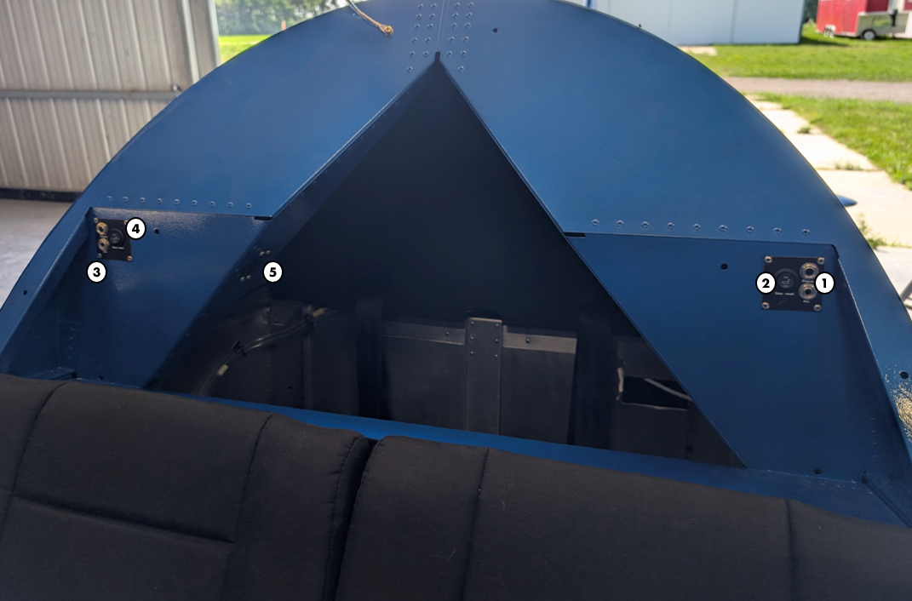

- Pilot Headset Connectors  - Pilot Seat Heat Switch  - Copilot Headset Connectors | - Copilot Seat Heat Switch  - ELT Control Panel

Instrument Panel Component Diagram

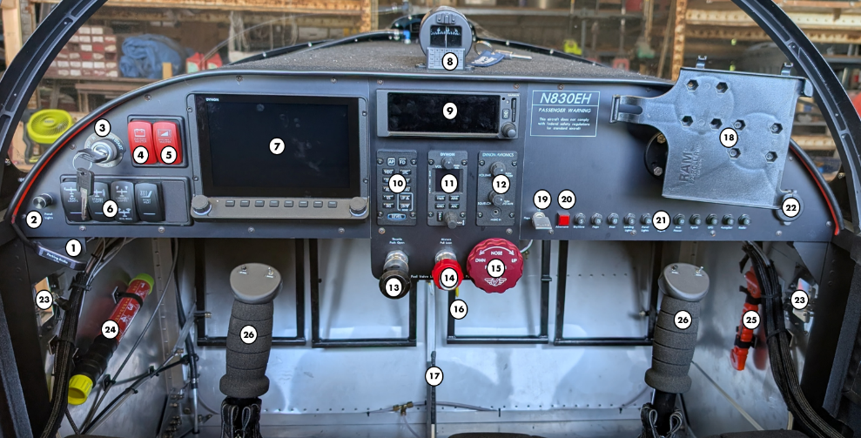

- Parking Brake  - Panel Light Dimmer  - Ignition Switch  - Master Switch  - Avionics Master Switch  - Component Switches  - Primary Flight Display  - Magnetic Compass  - Garmin GPS175 | - Autopilot Panel  - Com Radio  - Intercom  - Throttle  - Mixture  - Pitch Trim  - Fuel Shutoff Valve  - Brake Handle  - iPad Mount | - Flap Switch  - Alternator Reset Button  - Circuit Breakers  - Power Outlet  - Air Vents  - Fire Extinguisher  - Crash Hammer  - Control Sticks

Flight Instruments
The aircraft is equipped with a Dynon SkyView HDX avionics system that functions as the primary flight display and flight instrument, engine monitoring instruments, and a supplemental source of navigation. The system consists of multiple modules connected to a common network that communicates the SkyView HDX display. The SkyView network is designed to continue to work properly in the event of wiring or module faults by utilizing multiple power pathways and a redundant data network. The following section provides a general overview of the various parts of the system as well as a theory of operations. For more information regarding operation of the system, refer to the current revision of Dynon’s SkyView HDX Pilot’s User Guide.
Skyview HDX Display Unit
The SkyView HDX display unit installed in the pilot's position is designated the Primary Display and is capable of automatic screen backlight level management. It is configured during initial setup to always present PFD. It can also present map and engine monitoring. User interaction takes place via the two knobs, two buttons integrated into the knobs, and eight buttons along the bottom of the SkyView HDX display’s bezel and via touch gestures on the display screen itself. SkyView HDX provides a synthetic vision representation of the local terrain and obstacles. This display is for advisory purposes only and must not be used as the sole means of avoidance. SkyView HDX can present a Map to display airport, airspace, obstacle, and other available aviation data using navigation databases (FAA Obstacle/Terrain and Airport) databases and GPS-derived airplane position data. The Map can also be used for flight planning and plot navigational course guidance. The Map is for advisory purposes only and must not be used as a sole means of avoidance, nor is it an IFR-approved navigation source. Terrain clearance alerts are provided based on the predicted path of the airplane relative to the terrain database and the proximity of the aircraft to terrain. The synthetic vision alert is based both on altitude and on flight path. Terrain shown in red is an immediate threat to the aircraft. The map alert is based solely on GPS altitude.
- Yellow terrain is between 100 and 1000 feet below aircraft GPS altitude.
- Red terrain is above the aircraft, or 100 feet or less below the aircraft.
Terrain advisories are configured per pilot preference during initial system setup, and they are enabled from the MENU under MAP LAYERS. When enabled, terrain alerts are suppressed prior to takeoff and are enabled approximately 200 feet above the takeoff altitude. Terrain alerts are provided any time they are enabled, even if topographical relief is not shown on the map. SkyView HDX can display traffic information on the PFD and on the Map. The presentation of traffic information is for advisory purposes only and must not be used as a sole means of avoidance. SkyView HDX can also display weather information on the Map, including lightning and PIREPS.
The flight crew alerting system is a central feature of the SkyView HDX system. This system provides the pilot with system information organized by condition priority for all installed SkyView components. The alerts and messages will vary depending upon the installed equipment. System information is delivered in the form of flight crew alerts and messages that are organized by severity into one of three categories:
- Warning alerts are for conditions that require immediate flight crew awareness and immediate flight crew response.
- Caution alerts are for conditions that require immediate flight crew awareness and subsequent flight crew response.
- Messages are for conditions that require immediate flight crew awareness and may require subsequent flight crew response.
Whenever a new non-flightpath alert is triggered, the alert notification indicator (i.e., button label), flashes Red for Warning alerts, Yellow for Caution alerts, and Gray for Messages. A corresponding voice aural annunciates a spoken word such as "WARNING", "CAUTION" or "MESSAGE" depending on the alert type. Some alerts and messages will annunciate the actual name, such as "OIL PRESSURE", or "AUTOPILOT DISCONNECT". Pressing the WARNING, CAUTION, or MESSAGE button opens the alert notification window. This window displays text associated with each active alert. After pressing the button, the alerts present in the window are considered acknowledged and the indicator stops flashing. The indicator color corresponds with highest alert level that is currently being triggered. Individual alerts may be configured by the installer to require acknowledgement after they have been triggered for the alert to disappear.
The SkyView HDX display records and stores flight information in several data logs which can be exported for analysis by the owner, and a high-resolution data log which can be used by Dynon for troubleshooting.
A SkyView Wi-Fi adapter is installed in the SkyView HDX display and allows supported devices with supported apps to exchange data with SkyView. The default Wi-Fi password set is “Sonex0849B”.
Backup Battery System
An SV-BAT-320 backup battery is installed allowing the SkyView HDX display to be powered up without energizing the avionics bus, such as to monitor engine parameters during engine start. If avionics power is lost in flight, a properly operating SV-BAT-320 can provide power to a SkyView HDX display, SkyView Network modules, and an SV-GPS-250 GPS receiver for at least 60 minutes. The SV-BAT-320 is automatically (re)charged by the SkyView HDX display during flight.
Flight Data Module
The primary flight instruments on the SkyView PFD are generated using a group of calibrated sensors built into the SV-ADAHRS-200 ADAHRS module. All sensors are solid state – that is, there are no moving parts. These sensors include accelerometers, which measure forces in all three directions; rotational rate sensors, which sense rotation about all three axes; pressure transducers for measuring air data; and magnetometers on all three axes for measuring magnetic heading.
The SkyView artificial horizon display (attitude) is generated via a complex algorithm using a multitude of sensors. In normal operation, SkyView uses airspeed to provide superior attitude accuracy. Should airspeed become unavailable due to inadvertent blockage of the pitot system, GPS ground speed will be used as an attitude aid. CHECK PITOT HEAT will be annunciated on the PFD when this mode is in effect.
The SV-ADAHRS-200 unit is mounted behind the baggage compartment in an area with minimal magnetic interference. The ADAHRS unit also utilizes an outside air temperature (OAT) probe mounted on the right-hand side of the fuselage.

SkyView GPS Receiver
The SV-GPS-250 GPS module is an externally mounted GPS receiver designed specifically for use with SkyView systems and is designated as “SKYVIEW”. The module is powered by the SkyView HDX display (and thus will provide position updates when the SkyView HDX display is operating on battery backup power). It outputs GPS data to SkyView in NMEA format and automatically sets the time on the SkyView HDX display. To improve positional accuracy, it receives Wide Area Augmentation System (WAAS) GPS correction signals (where WAAS is available). The ability to receive WAAS GPS correction signals does not allow the SV-GPS-250 to be used as a primary navigation source in an IFR environment where a TSO’d WAAS GPS may be required.
Engine Data Module
The engine gauges on the SkyView ENGINE Page are generated from the data acquired by the SV-EMS-220 engine monitoring module and their connected sensors. This module measures a variety of engine and environmental parameters, such as: RPM, oil temperature and pressure; exhaust gas temperatures (EGT), cylinder head temperatures (CHT), fuel levels, voltage and current, fuel flow, flap position potentiometer, and general-purpose temperature sensors. The SV-EMS-220 module sends this information to other components via the SkyView network.
The SkyView HDX display unit is configured to indicate aircraft limitations described in Section 2 of the Aircraft Operating Handbook. The only colors used to express these limitations are red (do not exceed), yellow (caution range), and green (normal operating range). Engine information can be displayed in the 50% screen format or on a bottom engine information band on the PFD primary view screen.

Avionics
Transponder
A Dynon SV-XPNDR-261 class 1 remote mounted Mode-S transponder is located on the fuselage floor behind the seat pan. The transponder has traditional transponder feature along with ADS-B Out capability via 1090 ES and TIS-A traffic input capability. Control of the remote mounted transponder is accomplished through the Dynon SkyView PFD. The transponder is powered via the “Avionics Master” switch on the left side of the instrument panel and the “Xpndr” circuit breaker on the right side of the instrument panel.
ADS-B Receiver
A Dynon SV-ADSB-472 remote mounted ADS-B receiver is located on the fuselage floor behind the seat pan. The unit receive traffic and weather information from the Automatic Dependent Surveillance – Broadcast (ADS-B) system on both the 978 MHz and 1090 MHz bands and allows integrated traffic (TIS-B) and NEXRAD weather data to be displayed on the SkyView HDX display. The transponder is powered via the “Avionics Master” switch on the left side of the instrument panel and the “Xpndr” circuit breaker on the right side of the instrument panel.
COM Radio
A Dynon SV-COM-T25 remote mounted radio transceiver is located on the fuselage floor behind the seat pan. The unit is TSO’d and is controlled by either the Dynon SV-COM-PANEL located in the center section of the instrument panel or controls integrated into the PFD. The radio control head has the ability to tune frequencies by querying an aviation database installed in the SkyView HDX system. A dual watch feature allows the radio to monitor the standby frequency for transmissions while simultaneously monitoring the active frequency. During dual watch operation, the radio gives the active frequency priority and blocks the standby frequency when transmissions are being received on both frequencies simultaneously. The radio unit is powered via the “Avionics Master” switch on the left side of the instrument panel and the “Radio” circuit breaker on the right side of the instrument panel. Power for the radio control head is provided by the Dynon SkyView network.
Intercom
A Dynon SV-INTERCOM-2S intercom system is located in the center section of the instrument panel. The two-place stereo intercom system has inputs for SkyView system audio alerts, stereo music, and other mono muting and non-muting inputs. Volume and squelch controls are located on the intercom control panel along with a 3.5mm music input. The intercom is powered via the “Avionics Master” switch on the left side of the instrument panel and the “Radio” circuit breaker on the right side of the instrument panel.
Each occupant is provided with a microphone and headset jack for aviation-style headsets and are located on sub panels located over each occupant’s outside shoulder on the turtledeck former sub panel. Independent push-to-talk buttons for each pilot are located on the forward side of the stick grips. The system is wired so that the microphones are all voice-activated.
Garmin GPS 175
The Garmin GPS 175 navigation system is a GPS system with a Satellite Based Augmentation System (SBAS) comprised of a Garmin TSO-C146e navigator and a Garmin approved GPS/SBAS antenna(s) and is designated as “GPS175”. The GPS 175 system is capable of primary GPS navigation (Enroute), lateral approaches (LP/LNAV), and approaches with vertical guidance (LNAV/VNAV,LPV). A Dynon SV-ARINC-429 interface device is located behind the instrument panel and allows information from the GPS 175 to be used within the SkyView system and displayed on the PFD via the ARINC aviation protocol. The GPS unit is powered via the “Avionics Master” switch on the left side of the instrument panel and the “GPS” circuit breaker on the right side of the instrument panel.

Autopilot
The SkyView Autopilot system is a digitally controlled two-axis (roll and pitch) control system that provides flight path control functions to the pilot. The autopilot can follow a heading by reference to the compass, follow direction over the ground by reference to GPS track information, or navigate according to a CDI when coupled to SkyView’s internal VFR GPS navigation data or Garmin GPS 175 external IFR navigation data. The autopilot can hold altitude, and transition between altitudes at either a selected climb rate or airspeed. The autopilot will also follow vertical guidance including glideslope and glidepath information when coupled to an external navigation source. SkyView Autopilot does not control throttle; pilot action is required to modulate throttle.
All autopilot modes are annunciated visually on the PFD in a space reserved specifically for this purpose called the autopilot information bar. Visual and voice aural alerts are provided when the autopilot is engaged, disengaged, the autopilot mode is changed, or the autopilot encounters a limit condition. In the event of a mechanical jam or failure in the servo motor, there is a frangible link called a shear screw for each servo that can be broken by the pilot. This frees the controls from the servo so that the airplane can continue to be flown manually.
The autopilot automatically protects the aircraft envelope while the autopilot is engaged. The autopilot will not, however, self-engage to protect the aircraft envelope while flying manually. The autopilot provides G limit protection by keeping total vertical acceleration of aircraft between 0G and +2G, airspeed protection by limiting the airspeed between V_{NE} - 5% and V_{S0} + 30%, bank limit protection of 35°, and takeoff protection by disengaging if engaged when airspeed comes alive (~20 kts) to prevent the airplane from taking off with the autopilot engaged.
The autopilot may be activated and deactivated by the pilot by several means, including on-screen AP icons, a push button mounted on each control stick, as well as the SV-AP-PANEL/V autopilot control panel located in the center section of the instrument panel. The autopilot servos are located underneath the forward seat pan and are attached to the control stick frame by pushrods. The autopilot system is activated via one of the methods described above and is powered by the “Autopilot” circuit breaker on the right side of the instrument panel.

Emergency Locator Transmitter (ELT)
The airplane is equipped with a self-contained emergency locator transmitter (ELT). The transmitter and antenna are installed in the tail cone underneath the vertical stabilizer behind the tail fairing panels. The main transmitter control switch, labeled ON-OFF-ARMED, on the transmitter is in the armed position for normal operations. A remote control panel indicator and audio alert unit are installed on the inside edge of the right side turtledeck former. The transmitter unit is mounted longitudinally in the airplane to detect rapid deceleration. If rapid deceleration is detected, the transmitter will repeatedly transmit VHF band audio sweeps at 121.5 MHz and 406.037 MHz approximately 0.5 seconds apart. A replaceable lithium battery contained within the transmitter unit power the ELT transmitter and remote switch indicator panel. The battery must be replaced at specified intervals based upon the date appearing on the battery. Batteries are also used in the remote control panel indicator and audio alert unit and should be replaced based upon the date appearing on the batteries.
The ELT remote control panel indicator provides test and monitoring functions for the ELT. The panel contains a button labeled ON, a button labeled RESET, and a red LED (light). The red light flashes when the ELT is transmitting. The ON button is used to test the unit in accordance with the ACK installation manual. The RESET button can be used to cancel an inadvertent transmission. In the event of an accident, verify ELT operation by noting that the ELT indicator light on the remote panel is flashing.

Magnetic Compass
A conventional, internally lighted, liquid filles, magnetic compass is installed on top of the instrument glareshield in the center of the aircraft. A compass correction card is installed with the compass.

Pitot-Static System
The pitot-static system consists of a single heated pitot tube mounted underneath the right wing. The pitot heat is controlled through a panel-mounted rocker switch and circuit breaker, and the status is monitored through the Dynon SkyView system. The controller for the heated pitot mast is mounted within the internal right-wing structure and is accessible through an access panel on the lower portion of the wing skin. Pitot pressure (along with angle of attack pressure) is carried from the pitot mast to the SV-ADAHRS-200 module through Tygon tubing. The static pressure system does not rely on an externally mounted fixture. Rather, the ADAHRS unit static source is open to the aft fuselage area which provides an accurate static pressure measurement.
The heated pitot probe utilizes a heating element whose temperature is accurately measured and regulated by a microprocessor-based controller. The controller monitors a temperature sensor embedded within the pitot body to regulate the heat for the front half of the Probe to a constant temperature. This technique ensures that the pitot can be rapidly de-iced if required but does not needlessly waste electrical power. While the probe does not operate like a normal (when switched on, always hot) heated pitot, it will still get hot in normal ambient temperatures. When turned on, it will soon regulate its internal temperature to about 158° F to 176°F. Initial temperatures can be as high as 194°F. These temperatures can cause a burn if touched with bare skin for long. The controller is designed to meet the indication requirements of FAR 23.1326 by providing an output that can illuminate a PITOT HEAT STATUS warning indicator in the cockpit whenever the probe heater is turned off or is not functioning properly. Power for the pitot heat system is protected by the “Pitot Heat” circuit breaker on the right side of the instrument panel and is controlled by the “PITOT HEAT” rocker switch located on the left side of the instrument panel.

Stall Warning System
The airplane is equipped with a stall warning system with information derived from the angle of attack system integrated into the Dynon SkyView system. The Dynon Avionics AOA/Pitot probe performs two functions: airspeed sensing and angle of attack sensing. These functions require having two pressure ports on the tip of the probe. The normal pitot pressure port is on the front face of the probe and is designed to be insensitive to angle of attack. The second pressure port is located on an angled surface just under the pitot port and is designed to be very sensitive to AOA. The pressure from each port is delivered via separate pneumatic lines to the SkyView System’s ADAHRS module. Those pressures are compared to previously calibrated scenarios specific to that aircraft to calculate the current angle of attack.
Angle of attack is displayed as a vertical color-coded tape with a red stall zone, yellow warning zone, and a green safety zone. An audio alarm is also generated as AOA becomes critical. It is configured as a progressive beeping tone that starts as AOA becomes moderately high and increases in frequency until it is a solid tone very near the critical AOA.

Landing Gear
The main landing gear are constructed of 1.125” diameter 6AL-4V annealed titanium round bar and are bolted to engine mount near the firewall. Each main gear wheel has a 5.00 x 5 tire with innertube installed and aluminum fairing that attaches to the bottom of the fuselage and wheel pant via brackets. A hydraulically operated, single-disc type brake is installed on the inside of both main gear wheels. Standard wheel pant fairings can be mounted to attach plates that are mounted to each axle end. If desired, the wheel pants may be removed and the aircraft flown without them.
The tail gear is constructed of a 5/8” diameter 6AL-4V annealed titanium round bar and is bolted to the tail wheel mount assembly located on the bottom of the aft fuselage. The steerable tailwheel is comprised of a 6” x 2.1” solid wheel mounted to a machined tail wheel caster assembly. Unlike other tail wheel aircraft, the tailwheel is not fully castering and is steered directly by a pushrod connected to the rudder horn. The tailwheel is steerable through an arc of approximately 50° (25° either side of center). Turning radius information is available in Section 1 of this Aircraft Operating Handbook.

Aircraft Canopy
WARNING: NEVER FLY THE AIRPLANE UNLESS THE CANOPY IS COMPLETELY CLOSED AND LOCKED!
The hinged aircraft canopy is the only means for occupants to enter or exit the aircraft. The canopy in hinged on the right side and swings up and over from left to right. The canopy is made of a blown sheet of acrylic and attached via screws to the machined aluminum canopy frame. A steel canopy restraint cable prevents the canopy from opening too far and causing damage to the canopy. Alignment pins installed on the bottom left-hand side of the canopy frame help to guide the canopy into the proper position when closing the canopy. A key lock is installed on the left side of the fuselage and prevents the canopy latch from moving aft to the unlocked position when the key lock is engaged. The same key operates both the canopy latch lock and the ignition switch.
A canopy latch system is integrated into the left side of the canopy frame and engages on two latch posts located on the upper longeron. The canopy latch has two slots with the lower set of slots used to keep the canopy open slightly for airflow during ground operations. The upper set of slots are used to fully close and latch the canopy. A spring mechanism biases the canopy latch forward to the locked position. A lock pin is inserted into the canopy frame behind the forward slots to prevent the canopy latch from sliding backwards to the unlocked position. Prior to takeoff, verify that the canopy is fully closed and locked with the lock pin inserted. Failure to do so may result in injury or death!

Securing the Canopy for Flight
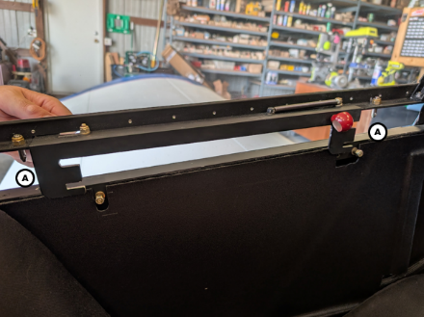Step 1: Guide the canopy alignment pins (A) into the corresponding holes in the upper longeron. | 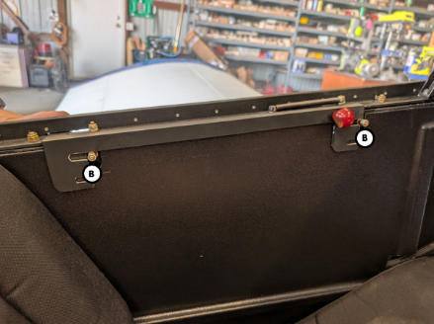Step 2: Align the top slots in the canopy latch with the latch posts on the cockpit side rail (B)
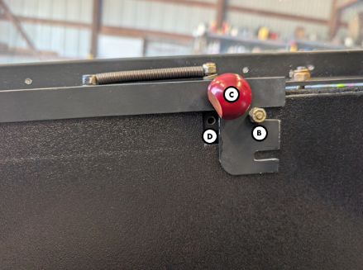Step 3: Push the canopy latch handle (C) fully forward so the slot in the latch engages the latching posts (B). The canopy is fully latched when the lock pin hole (D) is fully visible. | 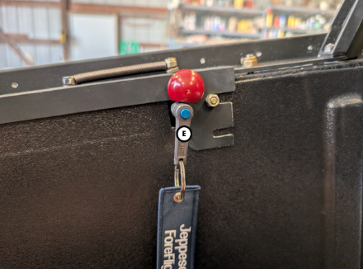Step 4: Lock the canopy by inserting the lock pin (E) into the lock pin hole located in the canopy rail.

Securing the Canopy Externally
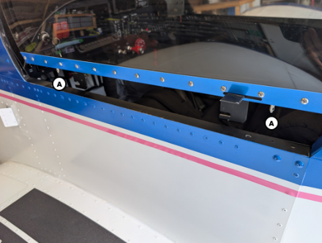Step 1: Guide the canopy alignment pins (A) into the corresponding holes in the upper longeron. | 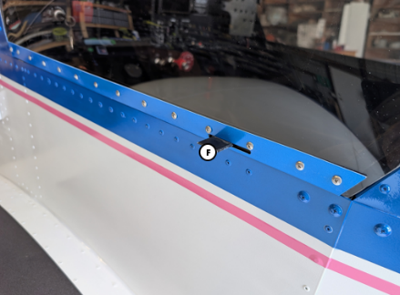Step 2: Slide the exterior handle (F) forward to latch the canopy from the outside

Seats
The seating arrangement consists of one fixed bench seat for both aircraft occupants. Seating position is fixed, and no seat adjustment features are available. Each “half” of the single seat is equipped with an imbedded heating element controlled by independent seat heat switches located over each occupant’s outside shoulder on the turtledeck former sub panel. Each switch has three positions offering low power (down), off (middle), and high power (up). Power for the seat heaters comes from the main bus through the aux fuse box.

Seatbelts
Integrated, adjustable seat belts and shoulder harnesses are provided for both aircraft occupants. The shoulder harnesses are attached to attach angles located in the aft fuselage and the lap belts are fastened to attach angles located on the fuselage side walls and structure underneath the aft seat pan.
To fasten the seatbelts:
- Place the shoulder harnesses over your shoulders ensuring webbing is straight with no twists. The metal tabs at the far end of the restraints should face toward each other.
- Take the tab end of the lap belt and feed the tab through both metal slots of the shoulder harness.
- Firmly insert the tab end of the lap belt into to buckle end.
- Grasp both seat belt tabs and pull to tighten the lap belt. The buckle should be centered over the hips for maximum comfort and safety.
- Grasp both shoulder harness tabs and pull downward to tighten the shoulder straps.
To release the seatbelts:
- Grasp the open end of the buckle and pull outward. The tab end of lap belt will slip free of the buckle.
- Set shoulder restraints aside.

Baggage Compartment
The baggage compartment extends from behind the forward most cross ties to the forward edge of cross ties #1 (station 95” to 114”). Access to the baggage compartment is gained through the flight deck area between the turtledeck formers and above the upper crosstie. The approximate dimensions of the baggage area are 36 inches wide by 19 inches deep by 21 inches tall, amounting in approximately 8.3 cubic feet of storage space. An aluminum cover protects the elevator push rod which runs through the center of the baggage compartment. Prior to flight, ensure all baggage items are secured; failure to do so may pose a projectile hazard to cabin occupants in the event of rapid deceleration. The baggage area has a maximum weight limit of 40 lbs.

Cabin Safety Equipment
Fire Extinguisher: In case of emergency, a potassium salt jet portable fire extinguisher (Element Type) is located on the left-hand forward fuselage wall near the pilot’s left knee. It uses a Potassium salt jet (a unique method among fire extinguishers) that employs the vaporization of the salt in the environment followed by the condensation of its extinguishing substance. This works by interrupting a fire’s chain of reaction (the “auto-catalyst” of the fire). The Element brand extinguisher is composed of stable, solid minerals; it does not contain gas and is not pressurized. The aerosol-like jet is only produced when the charger is struck with its base. The produced jet is free of thrust and is essentially an inert salt that emits gas already present in the atmosphere. This process allows Element to extinguish all types of fires through saturation, while its slow biodegradation in the environment, furthers the prevention of subsequent fires. To use the extinguisher in case of a fire emergency, remove the cap, remove starter from handle base, press starter to tip and scratch, and point discharge at fire.
Emergency Egress Hammer: In the event of a mishap where the canopy is jammed or inoperable, an emergency egress hammer may be used to break through the canopy and/or windshield to provide an escape path. The hammer is located on the right-hand forward fuselage wall near the passenger’s right knee.

Engine
The aircraft is powered by a Jabiru Aircraft 3300, six-cylinder, normally aspirated, carbureted engine rated to 120 hp at 3,300 RPM. Jabiru Aircraft recommend a TBO of 2,000 hours with a top end overhaul done at 1,000 hours, or when engine condition indicates the need to overhaul earlier.
The crankcase halves, cylinder heads, crankshaft, timing gear cover and coil mounts – together with many smaller components are machined from solid. The sump (oil pan) is cast aluminum. The cylinders are machined from bar 4140 chrome molybdenum alloy steel, with the pistons running directly in the steel bores. The crankshaft is also machined from 4140 chrome molybdenum alloy steel, the journals of which are precision ground prior to being Magnaflux inspected. The camshaft is cast iron with induction hardened cam lobes and bearing journals.
The crankshaft is designed with a double bearing at the propeller flange end and a main bearing between each big end; it therefore does not have flying webs. 48mm main bearings are also of the automotive slipper type. Thrust bearings are located fore and aft of the front double bearing allowing either tractor or pusher installation.
Pistons are manufactured to Jabiru design by a major manufacturer, they are fitted with 3 rings, the top rings being cast iron to complement the chrome molybdenum cylinder bores. Valves are 7mm (stem diameter) which are purpose manufactured for the Jabiru engine.
The valve gear includes pushrods from roller hydraulic cam followers to forged steel valve rockers mounted on a shaft through a Teflon coated bronze-steel bush. Valve guides are manufactured from aluminum/bronze, as is found in larger aero engines and high-performance racing engines. Replaceable valve seats are of nickel steel and are shrunk into the aluminum cylinder heads. The valve gear is lubricated via the hollow pushrods.
Engine Oil System
An internal gear pump is driven directly by the camshaft & provides engine lubrication via an oil circuit which includes an automotive spin-on filter, oil cooler and in-built relief valve. A combination oil filler cap and dipstick are located on the right front of the engine and are accessed through a door on the top right side of the engine cowling. See sections 2 and 8 for more information regarding limitations and servicing instructions of the engine oil system. An oil separator system is installed on the lower right side of the firewall and is connected to the engine breather (located by the oil filler/dip stick tube) via a hose. Oil vapor from the oil breather is routed to the separator where it is collected in the catch can. A steel ball in the breather input port prevents excessive oil loss during inverted flight. An oil drain port on the bottom of the separator allows collected oil from the separator to be drained periodically. The vapor port vents vapor out the bottom of the aircraft without excessive oil residue.
Engine Cooling System
The standard engines are supplied with two Ram-air cooling ducts to facilitate the cooling of the engine and direct air from the propeller to the critical areas of the engine, particularly the cylinder heads and barrels. Aluminum baffles direct the incoming air to the engine and over the engine cylinder cooling fins where the heat transfer takes place. The heated air exits the engine compartment through two vents in the aft portion of the cowling. No movable cowl flaps are used.
Engine Fuel/Air Induction System
The fuel induction system comprises an Aero Conversions AeroInjector slide-type carburetor. The AeroInjector is precision machined from solid 6061 aluminum billets and premium Delrin. There are only two moving parts: a fuel/air “throttle slide” that moves with the cockpit throttle control and meters combustion air and fuel, and a tapered needle that moves with the cockpit mixture control to control in-flight mixture adjustments and serve as an idle cut-off valve. The throttle slide carries within it an infinitely adjustable tapered fuel needle. A clamp for the mixture cable is built into the body of the AeroInjector, and the throttle cable is attached to the throttle slide via a reversing bellcrank. By design, the AeroInjector is extremely resistant to icing. An air filter assembly is mounted directly on the intake side of the AeroInjector and filters intake air from inside the cowling. The air filter assembly features a removable element.
Following carburation, the fuel/air mixture is drawn through a swept plenum chamber bolted to the sump casting, in which the mixture is warmed prior to entering short stainless steel induction tubes attached to the cylinder heads.
Ignition and Starter System
The engine is fitted with a 1.5 kW starter motor, which is also manufactured by Jabiru and provides very effective starting. The engine has very low vibration levels, however it is also supported by four large rubber shock mounts attached to the engine mounts at the rear of the engine. Two engine-driven magnetos and two spark plugs in each cylinder provide fuel ignition. Normal operation is conducted with both magnetos, as more complete burning of the fuel-air mixture occurs with dual ignition.
Ignition and starter operation is controlled by a rotary-type switch located on the left side of the instrument panel. The switch is labeled OFF, R, L, BOTH, and START. The engine should be operated on both magnetos (BOTH position) except for magneto checks. The R and L positions are for checking purposes and emergency use only. When the switch is rotated to the spring loaded START position, (with the master switch in the ON position), the starter contactor is closed and the starter, now energized, will crank the engine. When the switch is released, it will automatically return to the BOTH position.
Engine Indication System
The engine is equipped with a suite of sensors to monitor performance and environmental parameters. Each sensor is connected to the Dynon the SV-EMS-220 engine monitoring module where the information is translated and relayed to the Dynon SkyView HDX PFD. See the Flight Instruments section of this chapter for more information.
Engine Preheat system
The engine is fitted with a Reiff HotStrip Oil Sump heating system. The system consists of two heating elements epoxied onto each side of the oil sump along with a small thermostat unit epoxied onto the left-hand side of the oil sump. All three units are connected to a three-pronged power cord accessible in the right-hand cowl exhaust vent outlet. For best results, place a blanket over the engine cowling and plug all cowl openings to retain heat in the engine compartment. Plug in the heater three to five hours before engine start. Maximum heating is achieved in ten to twelve hours. For safety, plug the preheat unit into a GFI outlet if possible. Access to the preheat plug is located inside of the right-hand cowl exhaust exit on the right side of the lower cowl near the battery charge port.
Engine Controls
The engine controls are easily accessible to either occupant on the lower edge of the center instrument panel. They consist of a throttle control and a mixture control. Engine power is controlled by a throttle cable which moves the throttle slide located inside the AeroInjector. The throttle is open in the full forward position and closed in the full aft position. A friction lock, which is a round knurled knob, is located at the base of the throttle and is operated by rotating the lock clockwise to increase friction or counterclockwise to decrease it.
The mixture control, mounted adjacent to the throttle control, is a red knob with raised points around the circumference and is equipped with a lock button in the end of the knob. The mixture control cable is attached to the fuel metering needle located in the AeroInjector. The rich position is full forward, and full aft is the idle cutoff position. For small adjustments, the control may be moved forward by rotating the knob clockwise, and aft by rotating the knob counterclockwise. For rapid or large adjustments, the knob may be moved forward or aft by depressing the lock button in the end of the control, and then positioning the control as desired.

Propeller
The airplane is equipped with a two bladed, fixed pitch, one-piece carbon fiber P-Tip propeller with leading edge protection. The propeller is 54 inches in diameter and manufactured by the Price Aircraft Company.
The droop P-TIP is to control the air spillage over the propeller tip. It delays the tip vortices which cause drag and turbulence within the propeller arc. A propeller, like a wing, works best when it has smooth air over the airfoil sections. The P-TIP delays the vortices, the propeller then has smooth air to provide best thrust and a pronounced reduction in propeller noise. An additional benefit of the P-TIP design is the volume of air the propeller produces. When air flows through a standard propeller, the airflow will "roll" over the propeller tip. As soon as it passes the tip it will tuck down behind the propeller blade giving a cone of air from the propeller smaller than the propeller diameter. By reducing propeller diameter there is less frontal area or flat plate drag on the aircraft. Higher top speeds are the result without sacrificing takeoff or climb.

Fuel System
The fuel system consists of a fuel storage tank, fuel shutoff valve, fuel flow and level sensors, and a single fuel sump. A 20-gallon usable roto-molded cross-linked polyethylene fuel tank is located inside the flight deck and installed under the glareshield forward of the instrument panel. The fuel tank has a filler cap and neck that passes through the glareshield just behind the upper firewall. An access door in the windshield is provided for fueling operations. Avoid spilling fuel on the windshield during fueling operations which can lead to crazing and/or cracking of the windshield. A vent for the fuel tank is located next to the fuel filler neck and routes through the flight deck where it terminates along the left-hand main gear leg under the fairing. Fuel system venting is essential to system operation. Blockage of the system will result in decreasing fuel flow and eventual engine fuel starvation and stoppage. A capacitance-type fuel quantity sensor is mounted within the fuel tank and sends fuel level information to the Dynon SkyView system.
Fuel flows by gravity from the wing tank through a finger strainer located within the bottom of the fuel tank to a fuel shutoff valve located just under the fuel tank behind the instrument panel. To enable fuel flow, push the yellow handle forward so that it is in line with the fuel lines. To shut off fuel flow, pull the yellow handle aft so that it is perpendicular with the fuel lines.
From the fuel shutoff valve, the fuel runs through a fuel flow transducer which measures the rate of fuel flow and sends that information to the engine monitoring module. From there, the fuel line passes through the firewall where a tee fitting sends contaminates down to the fuel sump located on the bottom left-hand side of the cowling. The fuel sump is located at the low point of the fuel system and allows draining of the system for maintenance and examination of the fuel in the system for contamination and grade. The fuel must be sampled prior to each flight with a sampler cup.
From the tee fitting, the fuel passes through a 40 micron fuel filter where it is then sent to the AeroInjector for atomization.
An insulating fire barrier wrap is applied to the fuel lines forward of the firewall to keep fuel temperature down and help prevent vaporization of the fuel. The following is a diagram of the aircraft’s fuel system:

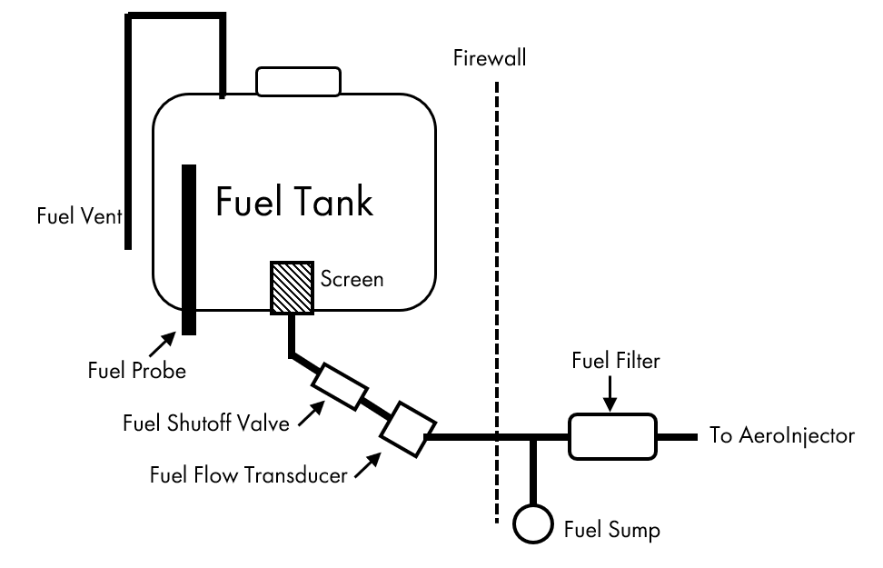Brake System
The main wheels are equipped with hydraulically operated, single-disc type brakes activated simultaneously by a floor mounted brake lever underneath the engine controls. A parking brake valve holds induced hydraulic pressure on the disc brakes for parking and is activated by a remote parking brake control located on the left side of the instrument panel. To set the parking brake, apply brake pressure by pulling the brake handle aft and pull the parking brake control out. To release the parking brake, push the parking brake control in. The brake system consists of a single master cylinder and integrated fluid reservoir, brake lever, parking brake valve, a single disc brake assembly on each main landing gear, and associated plumbing. Brake pressure is initiated by pulling the brake lever in the aft direction. See section 8 for information about servicing the brake system.
Brake system malfunction or impending brake failure may be indicated by a gradual decrease in braking action after brake application, noisy or dragging brakes, soft or spongy brake handle, excessive travel, and/or weak braking action. Should any of these symptoms occur, immediate maintenance is required.

Electrical System
The airplane is equipped with a single alternator, single battery, 14-volt direct current electrical system. The system is powered by a direct driven, 17-amp alternator and 14-volt battery, located on the right side of the firewall. Power is supplied to most general electrical circuits through a main bus bar and avionics bus bar.
Power Generation and Storage
An integral alternator using rare earth magnets provides alternating current for battery charging and electrical accessories. The alternator is attached to the flywheel and is driven directly by the crankshaft. The alternator output is controlled by a B&C Specialty Products voltage regulator mounted on the firewall. The regulator senses the aircraft’s electrical demand and matches the output of the alternator to electrical power demands. The voltage regulator is also equipped with dynamic over-voltage protection that will actively intervene in response to abnormal bus voltage. In the event the over-voltage protection feature is triggered, the unit will disconnect the alternator from the electrical system and will remain offline until the switch circuit is cycled. The regulator switch circuit is connected to ground through the “Alternator” reset button located on the right side of the instrument panel. In the event of a voltage regulator or alternator fault, the voltage regulator can be reset by pushing the red square reset button. A 22,000uF electrolytic capacitor is installed along-side the voltage regulator and helps reduce electrical “ripples” introduced into the aircraft bus by the alternator.
Power is stored in an aviation grade lithium iron phosphate (LiFePO₄) EarthX ETX900 battery rated for 840 pulse crank amps and 400 cold crank amps. The battery has a rated capacity 15.6 amp hours. The battery is equipped with an integrated battery management system which monitors the battery and electrical system for anomalies and has the ability to automatically remove the battery from the system. The battery management system integrates into the Dynon engine management module and will indicate “BMS CONTACT OPEN” on the PFD when a fault is detected. A built-in LED indicator located on the battery can indicate the type of fault detected by the battery’s microcontroller:
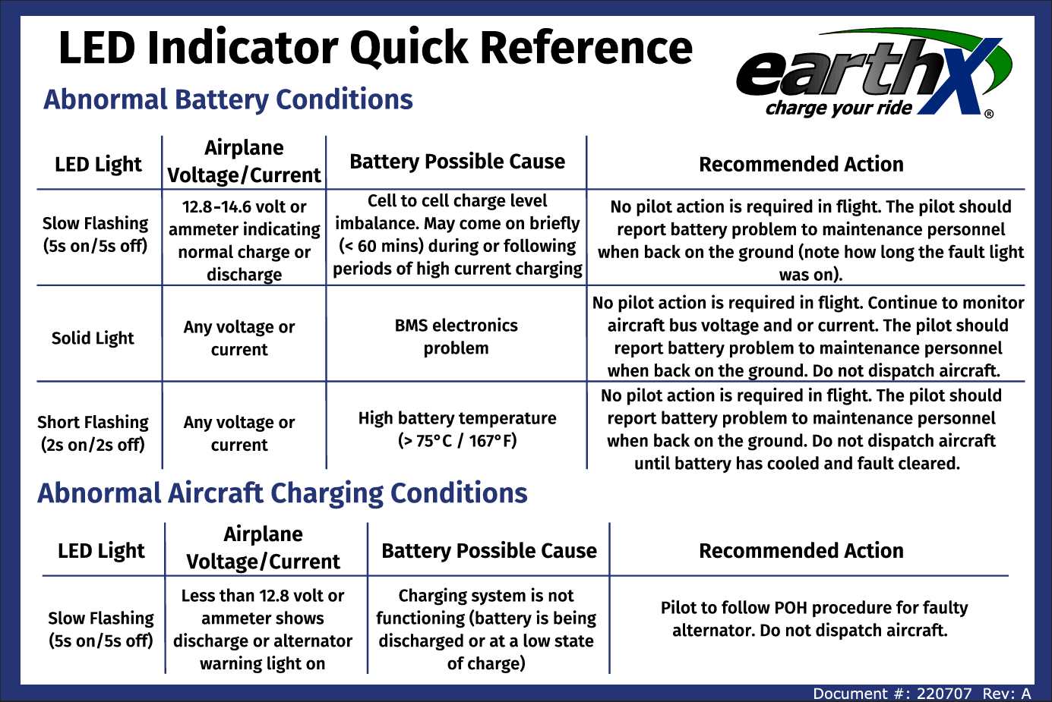
Power Distribution
From the battery and alternator/regulator, power passes through the master relay. The master relay is controlled by the red battery master switch, located on the left side of the instrument panel. Setting the battery master switch “on” (or up) energizes the master relay which connects the battery and alternator/regulator to the main bus. Connected to the main bus is a red avionics master switch. Setting the avionics master switch “on” (or up) connects the avionics bus to the master bus.
Individual electrical circuits connected to the main and avionics buses are protected by resettable circuit breakers mounted on the right side of the instrument panel.
A convenience outlet is installed on the right side of the instrument panel and offers 12-volt power to portable equipment via two USB-C and one USB-A connections. A separate 12-volt convenience outlet with a four-pin Deutsch-style connector is installed in the baggage compartment for use with the removable smoke system. Power for this component is continuously supplied while a switched ground signal wire is activated with a two-way switch on each control. Both convenience outlets are powered by the “Aux Power” circuit breaker.
An auxiliary fuse box with blade-style automotive fuses is located underneath the crosstie box and is powered from the “Aux Power” circuit breaker. Power for the heated seats and the smoke system is fed through this fuse box.
Power Indication
Voltage information is measured from the engine monitor module and displayed via the PFD. Amperage information is derived from an ammeter shunt installed between the master relay and alternator regulator. This information is also translated by the engine monitor module and shared with the Dynon SkyView system. The ammeter indicates flow of the electrical system from -60 amps to +60 amps. Negative amps displayed on the PFD indicate battery drain while positive amps indicate battery charge.
In addition to the battery fault indication and system described above, the Dynon SkyView system offers high/low voltage and amperage warnings and cautions. More information about these messages, warnings, and alerts is available in the Flight Instruments portion of this section.

Electrical Diagram
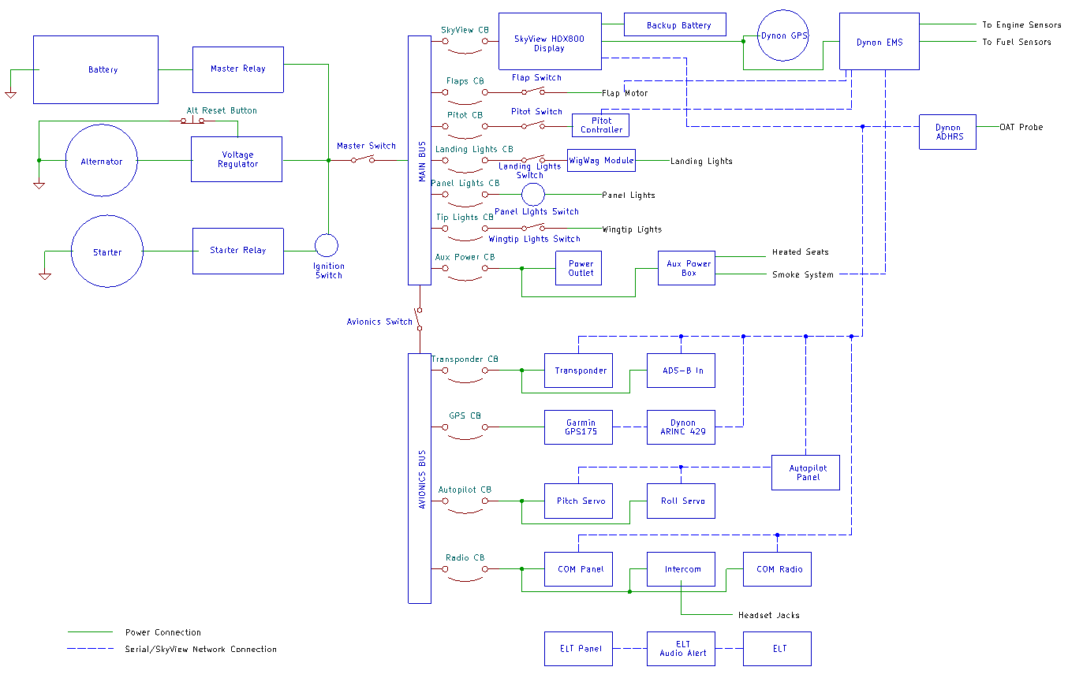

Lighting Systems
The airplane is equipped with standard wing tip LED navigation lights with position lights embedded in the rear of the light units. The navigation and position lights are controlled by the “NAV LIGHTS” switch located on the left side of the instrument panel. Anti-collision strobe lights are installed integral with the standard navigation lights. Each wing tip light has a built-in strobe power supply and a sync wire ensures the strobe flashes are consistent between the two lights. The strobe lights are controlled by the “STROBE LIGHTS” switch located on the left side of the instrument panel. Both functions of the integrated nav/position/strobe lights are powered via the “Wingtip Lights” circuit breaker.
Two LED landing lights are mounted on the outboard end of each wing tip. Each light is mounted behind a plexiglass lens on an adjustable fixture to allow for independent aiming of each landing light. The landing lights are connected to a wig-wag control module located behind the instrument panel. The wig-wag control module allows the landing lights to operate in “landing light” mode (both lights on continuously) or in “wig-wag” mode (each light alternates flashing for collision avoidance assistance). A landing light switch located on the left side of the instrument panel tells the control module which mode to operate in. The landing lights are off when the landing light switch is in the middle (neutral) position. Power for the landing lights and control module come from the “Landing Lights” circuit breaker.
A red LED strip is installed underneath the protruding edge of the glareshield to provide flood lighting to the instrument panel. The panel flood lights are controlled with a dimmer knob labeled “Panel Lights” located on the left side of the instrument panel. The rocker switches located on the left side of the panel are backlit to allow the labels to be read in low-light situations. Intensity of the backlights is also controlled by the panel light dimmer along with the integrated light in the magnetic compass. Power for the panel flood lights and switch backlights come from the “Panel Lights” circuit breaker. The Dynon SkyView PFD and Garmin GPS screens are backlight with intensity of the screen lighting controlled independently of each other or the panel light dimmer.

Environmental System
Ventilation air is provided by two fresh air vents located on each side of the forward fuselage underneath the instrument panel. To increase the opening of the fresh air vent and amount of fresh air coming into the cabin, push the block knob forwards and outwards to expose the vent door into the airstream. To decrease airflow, pull the black knob aft and inwards to close the vent door.
During ground operations, additional fresh air may be drawn into the cabin by locking the canopy in the lower latch slots, thereby leaving the canopy open approximately one inch. Prior to takeoff, verify that the canopy is fully closed and locked with the lock pin inserted. Failure to do so may result in injury or death!
Heating for both occupants is provided by independent heating elements embedded in each seat cushion. For more information on the seat heating system and controls, reference the “Seats” paragraph of this section.

Smoke System
This aircraft is equipped with a custom build exhaust smoke system with removable fluid tank and pump unit. The smoke fluid tank is a portable three-gallon marine gas can that is designed to fit snugly in the aft baggage compartment. Attached to the smoke fluid tank is 0.5 gallon per minute transfer pump, an electric solenoid valve, and a relay unit. The electric solenoid valve prevents fluid from being pulled through the system unless it is activated. The smoke system is powered via the aux fuse block and activated by a toggle switch on either control stick. Each toggle switch has two positions allowing the system to be “latched” on or momentarily switched on.
When the smoke system is activated, the transfer pump pulls fluid from the tank, through the pump, and then through the open solenoid valve where it is sent through PFTE tubing located on the left-hand side of the fuselage to the engine compartment. A tee fitting located on the left side of the engine mount splits the flow to sprayer assemblies located in each tail pipe. Each sprayer assembly is secured to an exhaust pipe via worm clamp and sealed with muffler sealant. Stainless steel tubing transition the sprayer assemblies to the PFTE tubing to protect it from heat.

[This page left blank]

Section 8: Handling, Servicing, and Maintenance

Introduction
This section provides general guidelines for handling, servicing, and maintaining this aircraft. Proper care, preventative maintenance, and routine inspections are necessary to maximize the reliability of the aircraft. Along with the information provided in this Aircraft Operating Handbook, the operator of this aircraft shall reference the applicable Federal Aviation Regulations to ensure all regulations are complied with.
Documents required to be kept on board the aircraft include the airworthiness certificate, federal aircraft registration, state aircraft registration, aircraft radio station license, operating limitations (including this handbook), and weight and balance data. These documents may be stored in the baggage compartment or in a document holder located on the right-hand fuselage side panel. Other non-required documents such as avionics pilots guides and checklists may be stored either in the aircraft or made available electronically on personal electronic devices.

Handling

Taxiing
While taxiing, it is important that speed and use of brakes be held to a minimum and that all controls be utilized to maintain directional control and balance. Taxiing over loose gravel or cinders should be done at low engine RPM to avoid stone damage to the propeller and undercarriage of the fuselage. Strong quartering tailwinds require caution. Use throttle and rudder to maintain directional control. The following control positions are recommended while taxiing:
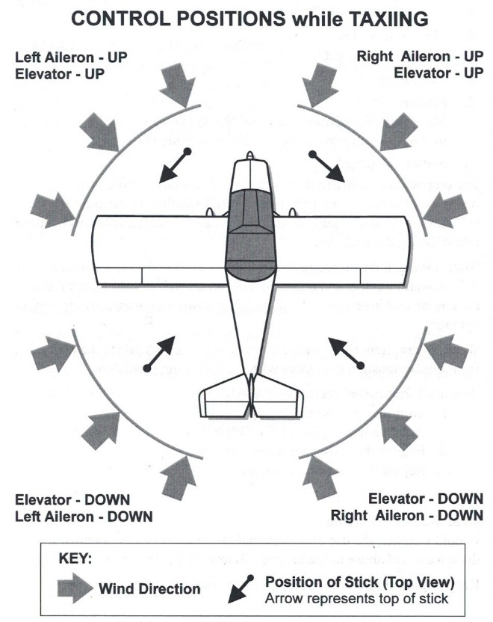

Towing
The airplane may be moved on the ground by the use of the tail wheel steering bar or by hand by lifting the tail at the tail spring. It is not recommended to use powered equipment to tow the airplane due to the direct steering feature of the tail wheel. The steering bar is engaged by inserting it onto the ends of the tail wheel bolt.
Do not use vertical or horizontal control surfaces, stabilizers, or the propeller to move the airplane. If a tow bar is not available, use the wing roots along the wing doublers or main gear legs as push points. Alternatively, to obtain a minimum radius turn during ground handling, the airplane may be rotated around either main landing gear by picking the tail up at the tail spring to raise the tail wheel off the ground.

Parking and Tie Down
The airplane should be parked to protect the airplane from weather and to prevent it from becoming a hazard to other aircraft. The parking brake may release or exert excessive pressure because of heat buildup after heavy braking or during wide temperature swings. Therefore, if the airplane is to be left unattended or is to be left overnight, chock and tie down the airplane. Do not set the parking brake during cold weather when accumulated moisture may freeze the brakes. If possible, the airplane should be parked into the wind to minimize control movement. The cowl plugs and pitot cover should be utilized any time the aircraft is left unattended to prevent creatures and contaminants from getting into the pitot/static system and cowling. A seatbelt may be used to secure the control stick in place to prevent damage during high wind conditions. The canopy should be locked when the airplane is unattended.
The airplane should be moored for immovability, security and protection. FAA Advisory Circular AC 20-35C, Tiedown Sense, contains additional information regarding preparation for severe weather, tiedown, and related information. Secure tie-down ropes to the wing tie-down rings and to the tail wheel assembly at approximately 45-degree angles to the ground. When using rope or non-synthetic material, leave sufficient slack to avoid damage to the airplane should the ropes contract. Use bowline knots, square knots, or locked slipknots. Do not use plain slipknots.

Leveling and Jacking
The airplane is leveled longitudinally by placing a spirit level on the upper forward fuselage longerons. This position can be maintained by placing a sawhorse underneath the rear fuselage with shims either under the sawhorse legs or underneath the fuselage. When using this method, ensure that the aircraft does not tip forward by strapping the tail spring down to a weight or the ground.
Jacking of the airplane to service the main landing gear may be accomplished by placing an RV-style scissor jack underneath either front corner of the aircraft where the firewall meets the lower longerons. Be careful not to place the jack underneath any part of the lower cowling. Additionally, take care to not crush the fuel breather when jacking on the front left corner of the fuselage.

Servicing

Tires
The main landing gear wheel assemblies use 5.00 x 5, four-ply rating tires and tubes. The tail wheel uses a solid 6-inch x 2.1-inch tire molded from 65 durometer SBR rubber. For maximum service from the main gear tires, keep them inflated to the proper pressure of XX psi. When checking tire pressure, examine the tires for wear, cuts, nicks, bruises and excessive wear.

Brakes
The brake system is filled with DOT 5 hydraulic brake fluid. The fluid level should be checked at every oil change and at the condition inspection, replenishing the system when necessary. The brake reservoir is integral to the master cylinder located on the floor in the cabin. A fill plug is located on the top of the unit to facilitate adding brake fluid to the system.
The brake assemblies and linings should be checked at each condition inspection (or as needed) for general condition, evidence of overheating, and deterioration. The aircraft should not be operated with overheated, damaged, or leaking brakes.

Propeller
The spinner and backing plate should be cleaned and inspected for cracks frequently. Before each flight the propeller should be inspected for nicks, scratches, and corrosion. If found, they should be repaired as soon as possible since a nick or scratch causes an area of increased stress which can lead to serious cracks or the loss of a propeller tip. To prevent corrosion, the surface should be cleaned and waxed periodically.

Oil
The oil capacity of the Jabiru 3300 engine is 3.7 quarts. It is recommended that the oil be changed every 25 hours and sooner under unfavorable operating conditions. The following grades are recommended for all ambient air temperatures at sea level: W100, W100 Plus, or multigrade 15W-50. See the Jabiru Engine Maintenance Manual for oil grade recommendations specific to operation type and temperature. Do not use any type of automotive oil as aviation oils have been blended specifically for the operating conditions found in air-cooled aero engine operations. In any case, oil used should be of SAE standard J-1899.
An oil dipstick is located at the right front of the engine and is accessible through an access door on the top right side of the engine cowling. The engine should not be operated with the oil level outside of the upper and lower marks on the dipstick.

Fuel
The recommended fuel types for this aircraft are aviation grade100LL (blue) or 100 (green) (avgas) or leaded and unleaded automotive gasoline (mogas) above 95 octane RON (AKI 90). For more detailed information regarding the use of mogas in the Jabiru engine, see Jabiru service letter JSL007. In any case, the use of ethanol is strongly discouraged. Observe all safety precautions required when handling gasoline. The fuel tank, located behind the instrument panel under the glareshield, holds a maximum of 20 gallons. Avoid spilling fuel on the windshield during fueling operations which can lead to crazing and/or cracking of the windshield.
To assure that the proper grade of fuel is used and that contamination is not present, the fuel must be sampled prior to each flight. Typically, fuel contamination results from foreign material such as water, dirt, rust, and fungal or bacterial growth. The fuel system drain must be sampled by draining a cupful of fuel into a clear sample cup. If sampling reveals contamination, the drain must be sampled again repeatedly until all contamination is removed. If after repeated samplings (three or more), evidence of significant contamination remains, do not fly the airplane until the fuel system is drained and purged, and the source of contamination is determined and corrected. To help reduce the occurrence of contaminated fuel coming from the supplier or fixed based operator, pilots should assure that the fuel supply has been checked for contamination and that the fuel is properly filtered. Also, between flights, the fuel tanks should be kept as full as operational conditions permit to reduce condensation on the inside of fuel tanks.

Battery
The EarthX lithium iron phosphate battery is designed to be maintenance free and does not require regular service. Charging is only required as needed. On an annual basis, visually inspect the battery for signs of damage and test the fault indicator as described in the EarthX Lithium Battery User’s Manual. If at any time the aircraft will not start or the battery seems low, charge it using a battery charger designed for lithium batteries (such as an Optimate charger). A quick connect charging port for use with an Optimate charger is provided inside of the right-hand cowl exhaust exit on the right side of the lower cowl.

Aircraft Exterior
The airplane should be washed with a mild soap and water. Harsh abrasives or alkaline soaps or detergents could make scratches on painted or plastic surfaces or could cause corrosion of metal. To wash the airplane, flush away loose dirt with water, apply cleaning solution with a soft cloth, a sponge or a soft bristle brush, and rinse all surfaces thoroughly. To remove stubborn oil and grease, use a cloth dampened with naphtha. Any good silicone free automotive wax may be used to preserve painted surfaces. Soft cleaning cloths or a chamois should be used to prevent scratches when cleaning or polishing. A heavier coating of wax on the leading surfaces will reduce the abrasion problems in these areas.

Canopy and Windshield
The plexiglass canopy should be cleaned with soap and water. Do not rub the canopy with a dry cloth since this builds up an electrostatic charge which attracts dust. Scratches, even deep ones, can be removed from the canopy with many readily available plastic restoration products.
The polycarbonate windshield should be cleaned with soap and water. Do not rub the windshield to remove spots as the soft surface of the windshield scratches easily and cannot be polished. Since the windshield is made of polycarbonate, it is far more prone to scratching than the canopy. Use extra care when cleaning the windshield.
For both the canopy and windshield, do not use gasoline, alcohol, benzene, carbon tetrachloride, thinner, acetone, or glass window cleaning sprays. Use only solvent-free, non-abrasive, antistatic acrylic cleaners (such as Prist Acrylic Plastic and Glass Cleaner) with non-abrasive cotton cloths or genuine chamois. When cleaning acrylic surfaces, use an up and down motion parallel to airflow; wiping with a circular motion can cause glare rings.

Maintenance

Maintenance Reference Documents
There are a number of standard reference materials available to the aircraft operator to assist in servicing, maintenance, and repair tasks including FAR Part 43: Maintenance, Preventative Maintenance, Rebuilding, and Alteration and Advisory Circular 43.13 Acceptable Methods, Techniques, and Practices - Aircraft Inspection and Repair. Several resources compiled during the build process are also available including a detailed build log, this Aircraft Operating Handbook, and wiring diagrams. In addition to these general references, the following publications should be referenced when maintaining the aircraft:
- ACK Technologies E-04 ELT Installation and Operation Manual (E04M)
- B&C Technical Manual for PMR1D (XB102-1) Voltage Regulator (XB102-1-TM)
- Dynon Heated AOA/Pitot Probe Installation Guide (100740-003)
- Dynon SkyView HDX System Installation Guide (101320-043)
- Dynon SV-INTERCOM-2S Installation and User Guide (102061-000)
- EarthX Lithium Battery User’s Manual (111017_AD)
- Garmin GPS 175/GNX 375/GNC 355 Part 23 AML STC Maintenance Manual (190-02207-A2)
- Garmin GPS 175/GNC 355(A)/GNX 375 Maintenance Manual (190-02207-01)
- Garmin GPS 175 Part 23 AML STC Installation Manual (190-02207-A1)
- Jabiru Installation Manual (JEM3302)
- Jabiru Maintenance Manual (JEM0002)
- Jabiru Overhaul Manual (JEM0001)
Service bulletins, service letters, and airworthiness directives should also be referenced and complied with as necessary to ensure safe and efficient operation of the aircraft. To ensure the most up-to-date information is available, ensure that sources of these types of information are checked periodically.

Airframe Inspection Scope and Interval
Federal Aviation regulations require an annual condition inspection be performed to the scope of FAR Part 43. This inspection must be conducted by an A&P mechanic or by the person holding the Repairman’s Certificate for this specific aircraft. Other inspections may also be required depending on airworthiness directives, types of operations, or installed equipment. It is the responsibility of the owner/operator to ensure compliance with all applicable inspections. Maintenance checklists are available to aid in inspection, maintenance, and repair tasks.

Powerplant Inspection Scope and Interval
In addition to the FAA mandated condition inspection, Jabiru has provided required inspection points and service manual for the Jabiru 3300 engine. The power plant must be maintained according to the recommendations specified by Jabiru in the current versions of the Jabiru Maintenance Manual and the Jabiru Overhaul Manual.

