Weight and Balance Report
Evan Krueger  538 Greenview Dr  Evansville, WI 53536  (608) 616-9391 | Aircraft: N830EH  Make: Krueger Evan M  Model: Sonex B  Serial Number: 0849B | Date: XX/XX/XXXX  Hobbs: 0.0

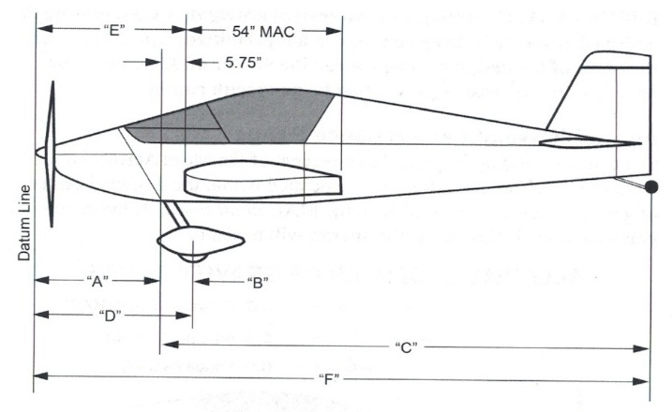 | Measured Distances
“A” =
“B” =
“C” =
 | Calculated Distances
[“D”] Main Gear Arm (A+B) =
[“E”] Leading Edge Datum (A+5.75) =
[“F”] Tailwheel Arm (A+C) =

Recorded Aircraft Weights
Weighing Point | Weight (lbs.) | Arm (in) | Moment
Left Main
Right Main
Tail Wheel
Total Moment:
Empty Weight:
Empty CG:

 | Utility Category | Aerobatic Category
Forward CG Limit | XX.X” (20% MAC) | XX.X” (23% MAC)
Aft CG Limit | XX.X” (32% MAC) | XX.X” (29% MAC)

Reason For Weighing: Initial weighing for airworthiness certification

Signature |  | Date

